Bangladesh Medical Association (BMA)
List of Life Member-325
55. BMA Rajshahi Branch

Sl No | Voter No | Voter Details
1 | Voter No  LM-5500001  No Image | DR. ANWARUL ISLAM  F/Name:  M/Name:  BM & DC Reg. No:  NID:  Cell:  Address: Shahid Alamgir Hostel, Professor Para, Rajshahi  Blood Group:
2 | Voter No  LM-5500002  No Image | DR. MD. MOIDUL ISLAM  F/Name:  M/Name:  BM & DC Reg. No:  NID:  Cell:  Address: Rajshahi Medical College, Rajshahi  Blood Group:  E X P I R E D
3 | Voter No  LM-5500003  No Image | DR. SANWAR HOSSAIN  F/Name:  M/Name:  BM & DC Reg. No:  NID:  Cell:  Address: Prof. Of Surgery Rajshahi Medical College, Rajshahi  Blood Group:
4 | Voter No  LM-5500004  No Image | DR. SULTANA RAFIA BEGUM  F/Name:  M/Name:  BM & DC Reg. No:  NID:  Cell:  Address: 2/E, Staff Quarter, Rajshahi Medical College, Rajshahi  Blood Group:
5 | Voter No  LM-5500005  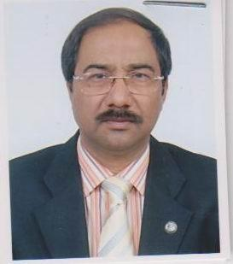 | DR. MD. DAYEM UDDIN  F/Name: Md. Durlov Uddin  M/Name: Mrs. Ohiron Begum  BM & DC Reg. No: A-13364  NID:  Cell: 01713202000  Address: Prof. & Head Of The Dept. Of Radiotherapy, Rajshahi Medical College & Hospital, Rajshahi.  Blood Group:
6 | Voter No  LM-5500006  No Image | DR. SHAH AMINUL ISLAM  F/Name:  M/Name:  BM & DC Reg. No:  NID:  Cell:  Address: Rajshahi Division, Rajshahi.  Blood Group:
7 | Voter No  LM-5500007  No Image | DR. MD. NAZRUL ISLAM  F/Name:  M/Name:  BM & DC Reg. No:  NID:  Cell:  Address: Nurullah Pathology, Greater Road, Laxmipur, Rajshahi  Blood Group:
8 | Voter No  LM-5500008  No Image | DR. AKHTER HOSSAIN  F/Name:  M/Name:  BM & DC Reg. No:  NID:  Cell:  Address: Associate Prof Of Medicine Rajshahi Medical College, Rajshahi  Blood Group:
9 | Voter No  LM-5500009  No Image | DR. MD. KAISAR RAHMAN CHOWDHURY  F/Name:  M/Name:  BM & DC Reg. No:  NID:  Cell:  Address: Ullara Clinic, Bilsimla Cloth Rd., Rajshahi  Blood Group:  E X P I R E D
10 | Voter No  LM-5500010  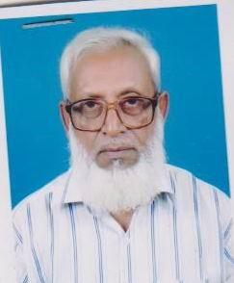 | DR. MD. ABDUL KADER  F/Name:  M/Name:  BM & DC Reg. No:  NID:  Cell:  Address: Residence Nirjhar Housing, D-443, Rajshahi  Blood Group:
11 | Voter No  LM-5500011  No Image | DR. ABU AHMED ASHRAF ALI  F/Name:  M/Name:  BM & DC Reg. No:  NID:  Cell:  Address: Rajshahi Medical College, Rajshahi  Blood Group:  E X P I R E D
12 | Voter No  LM-5500012  No Image | DR. SYED AMZAD ALI LITON  F/Name:  M/Name:  BM & DC Reg. No:  NID:  Cell:  Address: Ragistra, Neurosurgery Medical College, Rajshahi  Blood Group:
13 | Voter No  LM-5500013  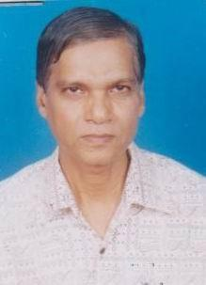 | DR. MD. WASIM HUSSAIN  F/Name:  M/Name:  BM & DC Reg. No:  NID:  Cell:  Address: Consultant TB. Clinic, Rajshahi  Blood Group:
14 | Voter No  LM-5500014  No Image | DR. MD. SHOHRAB HOSSAIN  F/Name:  M/Name:  BM & DC Reg. No:  NID:  Cell:  Address: TRANSFERED to BMA Dhaka City  LM-1401990  Blood Group:  TRANSFERED to BMA Dhaka City  LM-1405543
15 | Voter No  LM-5500015  No Image | DR. MD. SHAKILUR RAHMAN  F/Name:  M/Name:  BM & DC Reg. No:  NID:  Cell:  Address: Kazihata, Rajpara, Rajshahi  Blood Group:
16 | Voter No  LM-5500016  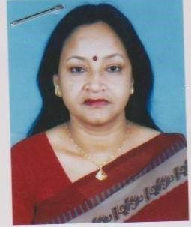 | DR. SHAHIN ARA  F/Name:  M/Name:  BM & DC Reg. No:  NID:  Cell:  Address: Kazihata, Rajpara, Rajshahi  Blood Group:
17 | Voter No  LM-5500017  No Image | DR. MD. FAZLUR RAHMAN  F/Name:  M/Name:  BM & DC Reg. No:  NID:  Cell:  Address: Associate Prof, Of Pathology Rajshahi Medical College, Rajshahi  Blood Group:
18 | Voter No  LM-5500018  No Image | DR. MD. MONIRUL HOQUE  F/Name:  M/Name:  BM & DC Reg. No:  NID:  Cell:  Address: Training Physician Dirrhoea Training Unit, RMC, Rajshahi  Blood Group:
19 | Voter No  LM-5500019  No Image | DR. MAMUN UR RASHID  F/Name:  M/Name:  BM & DC Reg. No:  NID:  Cell:  Address: Assistant Prof. (EC) Pharmacology, Rajshahi  Blood Group:  E X P I R E D
20 | Voter No  LM-5500020  No Image | DR. MD. MONSUR ALI  F/Name:  M/Name:  BM & DC Reg. No:  NID:  Cell:  Address: TRANSFERED to BMA Norshingdi Br. LM-4500016  Blood Group:  TRANSFERED to BMA Dhaka City  LM-1405543
21 | Voter No  LM-5500021  No Image | DR. MD. ABDULLAHEL KAZEM  F/Name:  M/Name:  BM & DC Reg. No:  NID:  Cell:  Address: Jebun Mansion, E-668, Rajarhat. Rajshahi  Blood Group:
22 | Voter No  LM-5500022  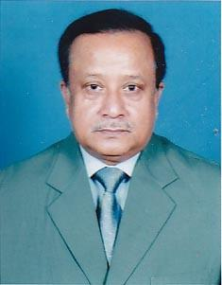 | DR. MD. ABUL KASEM PRAMANIK  F/Name:  M/Name:  BM & DC Reg. No:  NID:  Cell:  Address: 358/2, Housing Estate, Uposhahar, Rajshahi  Blood Group:  E X P I R E D
23 | Voter No  LM-5500023  No Image | DR. MD. ABDUL MUTTALIB  F/Name:  M/Name:  BM & DC Reg. No:  NID:  Cell:  Address: 356/2, Housing Estate, Uposhahar,Rajshahi  Blood Group:
24 | Voter No  LM-5500024  No Image | DR. NOOR MOHAMMAD  F/Name:  M/Name:  BM & DC Reg. No:  NID:  Cell:  Address: The Akota Clinic, Bar Kharboria, Rajshahi  Blood Group:  E X P I R E D
25 | Voter No  LM-5500025  No Image | DR. MD. HAMMAD ALI  F/Name:  M/Name:  BM & DC Reg. No:  NID:  Cell:  Address: Zobeda Villa, Laxmipur, Rajshahi  Blood Group:
26 | Voter No  LM-5500026  No Image | DR. MD. MIZANUR RAHMAN  F/Name:  M/Name:  BM & DC Reg. No:  NID:  Cell:  Address: TRANSFERED to BMA Dhaka City  LM-1861  Blood Group:  TRANSFERED to BMA Dhaka City  LM-1405543
27 | Voter No  LM-5500027  No Image | DR. MD. SHAMSUZZAMAN CHOWDHURY  F/Name:  M/Name:  BM & DC Reg. No:  NID:  Cell:  Address: Rajshahi Medical College, Rajshahi  Blood Group:
28 | Voter No  LM-5500028  No Image | DR. MOHAMMAD FARID UDDIN  F/Name:  M/Name:  BM & DC Reg. No:  NID:  Cell:  Address: Dept. of Physiciatry, Rajshahi Medical College, Rajshahi  Blood Group:
29 | Voter No  LM-5500029  No Image | DR. SYED AZAD ALI  F/Name:  M/Name:  BM & DC Reg. No:  NID:  Cell:  Address: Shahin Clinic, Greater Road, Rajshahi  Blood Group:  E X P I R E D
30 | Voter No  LM-5500030  No Image | DR. MOHAMMAD KHOWOJA NURUN NABI CHOWDHURY  F/Name:  M/Name:  BM & DC Reg. No:  NID:  Cell:  Address: Noor Mansion, Sepaypara, Rajshahi  Blood Group:
31 | Voter No  LM-5500031  No Image | DR. MUHAMMAD ZAHANGIR  F/Name:  M/Name:  BM & DC Reg. No:  NID:  Cell:  Address: Rajshahi Medical College, Rajshahi  Blood Group:
32 | Voter No  LM-5500032  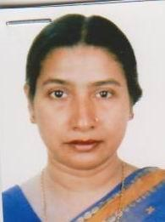 | DR. SALM-A ARJUMAND BANU  F/Name:  M/Name:  BM & DC Reg. No:  NID:  Cell:  Address: Registrar, Gynae-1 Rajshahi Medical College, Rajshahi  Blood Group:
33 | Voter No  LM-5500033  No Image | DR. MD. JAINUL ABEDIN  F/Name:  M/Name:  BM & DC Reg. No:  NID:  Cell:  Address: Medical Officer Rajshahi Medical College, Rajshahi  Blood Group:
34 | Voter No  LM-5500034  No Image | DR. MD. TOWHID HOSSAIN  F/Name:  M/Name:  BM & DC Reg. No:  NID:  Cell:  Address: Rajshahi Medical College, Rajshahi  Blood Group:
35 | Voter No  LM-5500035 | DR. HAFIZA KHATOON  F/Name:  M/Name:  BM & DC Reg. No:  NID:  Cell:  Address: Helalun Bhaban, Victoria Road, Ghoramara, Rajshahi  Blood Group:
36 | Voter No  LM-5500036  No Image | DR. A K M. RAFIQUE UDDIN  F/Name:  M/Name:  BM & DC Reg. No:  NID:  Cell:  Address: TRANSFERED to BMA Dhaka City  LM-1402090  Blood Group:  TRANSFERED to BMA Dhaka City  LM-1405543
37 | Voter No  LM-5500037  No Image | DR. MD. MOSTAQUE HOSSAIN ANSARI  F/Name: Dr. Ahmed Hossain Ansari  M/Name:  BM & DC Reg. No:  NID:  Cell:  Address: Lecturer Community Medicin RMC, Rajshahi  Blood Group:  E X P I R E D
38 | Voter No  LM-5500038  No Image | DR. IFTIKHAR AHMED  F/Name: Late Jahiruddin Ahmed  M/Name:  BM & DC Reg. No:  NID:  Cell:  Address: Associate Professor (CC) Microbiology Rajshahi  Blood Group:
39 | Voter No  LM-5500039  No Image | DR. MD. KHALILUR RAHMAN  F/Name: Md. Khapu Howlader  M/Name:  BM & DC Reg. No:  NID:  Cell:  Address: Rajshahi Medical College, Rajshahi  Blood Group:
40 | Voter No  LM-5500040  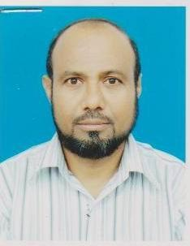 | DR. MD. ABDULLAH SIDDIQUE  F/Name: Late Abdul Ghafur  M/Name:  BM & DC Reg. No:  NID:  Cell:  Address: Assistat Profesor Microbiology RMC, Rajshahi  Blood Group:
41 | Voter No  LM-5500041  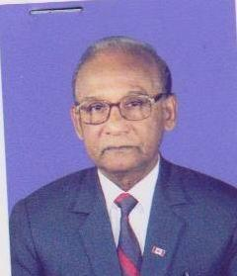 | DR. MD. RAFIQUL ALAM  F/Name: Late Dr. Momtaz Ali Sarkar  M/Name:  BM & DC Reg. No:  NID:  Cell:  Address: Assoc Prof Cmmunity Medisine RMC, Rajshahi  Blood Group:
42 | Voter No  LM-5500042  No Image | DR. MD. NAZMUL HAQUE  F/Name: Md. Azizul Haque  M/Name:  BM & DC Reg. No:  NID:  Cell:  Address: Asst. Prof Pathology Dept. RMC, Rajshahi  Blood Group:
43 | Voter No  LM-5500043  No Image | DR. ZUBAIR AHMED  F/Name: Md. Mommtas Hossain  M/Name:  BM & DC Reg. No:  NID:  Cell:  Address: Asst. Professor Dept. of Blood Transfusion, RMC, Rajshahi  Blood Group:
44 | Voter No  LM-5500044  No Image | DR. MD. SULTAN ALAM  F/Name: Late K M Ahsan Ali  M/Name:  BM & DC Reg. No:  NID:  Cell:  Address: House No- 38 Sector - 3 Upashahar Housing Estate, Rajshahi  Blood Group:
45 | Voter No  LM-5500045  No Image | DR. MUHAMMAD MAHBUB-UL-ALAM  F/Name: Alhaz Muhammad Kobad Ali  M/Name:  BM & DC Reg. No:  NID:  Cell:  Address: Vill- Luxmipur B-103, Shersha Road, GPO. Rajshahi  Blood Group:
46 | Voter No  LM-5500046  No Image | DR. MD. ABUL KASHEM SARKAR  F/Name: Md. Esahaque Ali Sarkar  M/Name:  BM & DC Reg. No:  NID:  Cell:  Address: Resedent Surgeon (S) RMCH, Rajshahi  Blood Group:
47 | Voter No  LM-5500047  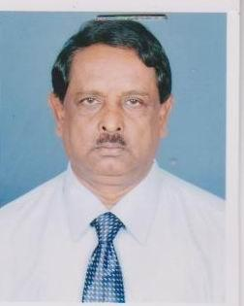 | DR. MD. FARRUQUE HOSSAIN  F/Name: Late Fazlar Rahman  M/Name:  BM & DC Reg. No:  NID:  Cell:  Address: Radiologist TB Hospital, Rajshahi  Blood Group:
48 | Voter No  LM-5500048  No Image | DR. FARID AHMED CHOWDHURY  F/Name:  M/Name:  BM & DC Reg. No:  NID:  Cell:  Address: TRANSFERED to BMA Sylhet Br.  LM-6500134  Blood Group:  TRANSFERED to BMA Dhaka City  LM-1405543
49 | Voter No  LM-5500049  No Image | DR. SHAMIM AHMED  F/Name:  M/Name:  BM & DC Reg. No:  NID:  Cell:  Address: TRANSFERED to BMA Dhaka City.  LM-1920  Blood Group:  TRANSFERED to BMA Dhaka City  LM-1405543
50 | Voter No  LM-5500050  No Image | DR. MD. ANWAR HOSSAIN  F/Name: Late Md. Osman Gani  M/Name:  BM & DC Reg. No:  NID:  Cell:  Address: Instt. of Health Technology, Rajshahi  Blood Group:
51 | Voter No  LM-5500051  No Image | DR. SAYERA KHATUN  F/Name:  M/Name:  BM & DC Reg. No:  NID:  Cell:  Address: TRANSFERED to BMA Dhaka City.  LM-2045  Blood Group:  TRANSFERED to BMA Dhaka City  LM-1405543
52 | Voter No  LM-5500052  No Image | DR. S. M. REZAUL ISLAM  F/Name: Md. Abdul Jabber Sarker  M/Name:  BM & DC Reg. No:  NID:  Cell:  Address: Civil Surgeon Office, Rajshahi  Blood Group:
53 | Voter No  LM-5500053  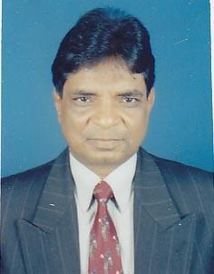 | DR. SUJIT KUMAR BHADRA  F/Name: Sj. Nalini Mohan Bhadra  M/Name:  BM & DC Reg. No:  NID:  Cell:  Address: Bosepara Ghoramara, Rajshahi  Blood Group:
54 | Voter No  LM-5500054  No Image | DR. MERINA KHANAM  F/Name: Md. Motiar Rahman  M/Name:  BM & DC Reg. No:  NID:  Cell:  Address: Asstt. Professor Gynae Obs Rajshahi  Blood Group:
55 | Voter No  LM-5500055  No Image | DR. MD. ABDULLAH AL AMIN  F/Name: Md Jakir Hossain  M/Name:  BM & DC Reg. No:  NID:  Cell:  Address: R M C H, Rajshahi  Blood Group:
56 | Voter No  LM-5500056  No Image | DR. TAHSIN ARA  F/Name:  M/Name:  BM & DC Reg. No:  NID:  Cell:  Address: TRANSFERED to BMA Dhaka City.  LM-1402077  Blood Group:  TRANSFERED to BMA Dhaka City  LM-1405543
57 | Voter No  LM-5500057  No Image | DR. MEER MAHBUBUL ALAM  F/Name: Meer Golam Mostafa  M/Name:  BM & DC Reg. No:  NID:  Cell:  Address: Assistant Professor Surgery RMC, Rajshahi  Blood Group:
58 | Voter No  LM-5500058  No Image | DR. MD. TAFIQ-UL-ISLAM KHAN (TI.KHAN)  F/Name: Late Md. Badruddin Khan  M/Name:  BM & DC Reg. No:  NID:  Cell:  Address: Mukti Clinic Pvt. Ltd., Lakshmipur, Rajshahi  Blood Group:
59 | Voter No  LM-5500059  No Image | DR. MD. RABI UL ISLAM KHAN SHOWPON  F/Name: Late Azizul Islam  M/Name:  BM & DC Reg. No:  NID:  Cell:  Address: Xylia Medicare, Laxmipur More, Rajshahi  Blood Group:
60 | Voter No  LM-5500060  No Image | DR. S M KHODEZA NAHER BEGUM  F/Name: Mr. MA Baker  M/Name:  BM & DC Reg. No:  NID:  Cell:  Address: Xylia Medicare, Laxmipur More, Rajshahi  Blood Group:
61 | Voter No  LM-5500061  No Image | DR. MD. MIZANUR RAHMAN  F/Name:  M/Name:  BM & DC Reg. No:  NID:  Cell:  Address: TRANSFERED to BMA Chittagong Br.  LM- 10  Blood Group:  TRANSFERED to BMA Dhaka City  LM-1405543
62 | Voter No  LM-5500062  No Image | DR. MD. NAWSHER ALI  F/Name: Md. Mohar Ali Biswas  M/Name:  BM & DC Reg. No:  NID:  Cell:  Address: 547 Proshanti, Rajarhata, PO.- Rajshahi, Rajshahi  Blood Group:
63 | Voter No  LM-5500063  No Image | DR. SAMIL UDDIN AHMED SHIMUL  F/Name: Moin Uddin Ahmed  M/Name:  BM & DC Reg. No:  NID:  Cell:  Address: Cure Nursing Home, 58-A Kazi Hata, Rajshahi  Blood Group:
64 | Voter No  LM-5500064  No Image | DR. MAHMUD ILAHI MAMUN  F/Name: Late A. A. M. Ilahi Buksh  M/Name:  BM & DC Reg. No:  NID:  Cell:  Address: Shapla Diagnostic Complex, Laxmipur, Rajshahi  Blood Group:
65 | Voter No  LM-5500065  No Image | DR. MD. TABIBUR RAHMAN SK.  F/Name: Md. Abdul Qudus Sk.  M/Name:  BM & DC Reg. No:  NID:  Cell:  Address: Rajshahi University Medical Centre, House # 246, Road # 3, P.S-Goaliour, Chandrima R/A, Rajshahi City Corporation, Rajshahi.  Blood Group:
66 | Voter No  LM-5500066  No Image | DR. REXONA KHATUN  F/Name: Late Md. Abdur Rashid  M/Name:  BM & DC Reg. No:  NID:  Cell:  Address: Lions Eye Hospital, Rajshahi  Blood Group:
67 | Voter No  LM-5500067  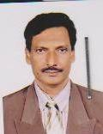 | DR. MD. ABDUL AWAL  F/Name: Late Shafi Uddin  M/Name:  BM & DC Reg. No:  NID:  Cell:  Address: Assistant Registrar S. U. III Rajshahi, Medical Hospital, Rajshahi  Blood Group:
68 | Voter No  LM-5500068  No Image | DR. CHINMOY KANTI DAS  F/Name: Late Makan Chandra Das  M/Name:  BM & DC Reg. No:  NID:  Cell:  Address: Medical Officer (CC) District FP Office, Rajshahi  Blood Group:
69 | Voter No  LM-5500069  No Image | DR. MD. SAIFUR RAHMAN  F/Name: : Md. Abdul Quader Sarker  M/Name:  BM & DC Reg. No:  NID:  Cell:  Address: Nawhata U. S. C. P.O. Lalitganj, Rajshahi  Blood Group:
70 | Voter No  LM-5500070  No Image | DR. SAYED SHAFIQUL ALAM  F/Name: Samued Ashraf Ali Alam  M/Name:  BM & DC Reg. No:  NID:  Cell:  Address: Ultra Diagnostic Complex, Medical College Road, Rajshahi  Blood Group:
71 | Voter No  LM-5500071  No Image | DR. EKRAMUL HAQUE  F/Name: Md. Monimul Haque  M/Name:  BM & DC Reg. No:  NID:  Cell:  Address: 15/19, Greater Road, Laxmipur, Rajshahi  Blood Group:
72 | Voter No  LM-5500072  No Image | DR. MUSTAFA TARIQUZZAMAN  F/Name:  M/Name:  BM & DC Reg. No:  NID:  Cell:  Address: TRANSFERED to BMA Mymensingh Branch LM-4100226  Blood Group:  TRANSFERED to BMA Dhaka City  LM-1405543
73 | Voter No  LM-5500073  No Image | DR. MD. TOFAZZAL HAQUE  F/Name: Md. Tozammel Haque  M/Name:  BM & DC Reg. No:  NID:  Cell:  Address: Medical Officer Sopd RMCH, Rajshahi  Blood Group:
74 | Voter No  LM-5500074  No Image | DR. MD. ABDUL WADOOD  F/Name: Md. Elahi Bakhsh Molla  M/Name:  BM & DC Reg. No:  NID:  Cell:  Address: Vill- & P/O Shyampur, Thana Motihar, Rajshahi  Blood Group:
75 | Voter No  LM-5500075  No Image | DR. MD. SHANJAD BIN INAM  F/Name: Late Dr. Inamul Haque  M/Name:  BM & DC Reg. No:  NID:  Cell:  Address: Health Office Kadirganj, Rajshahi  Blood Group:
76 | Voter No  LM-5500076  No Image | DR. KHONDAKER BULBUL SARWAR  F/Name:  M/Name:  BM & DC Reg. No:  NID:  Cell:  Address: TRANSFERED to BMA Dhaka City.  LM-1401887  Blood Group:  TRANSFERED to BMA Dhaka City  LM-1405543
77 | Voter No  LM-5500077  No Image | DR. MD. MOBIUL HAQUE HAIDARY  F/Name: Md. Mozzammel Haque  M/Name:  BM & DC Reg. No:  NID:  Cell:  Address: Assestant Prof. Paediatrics RMC.,Rajshahi.  Blood Group:
78 | Voter No  LM-5500078  No Image | DR. BIPUL KUMAR DAM  F/Name: Mr. Debendra Nath Dam  M/Name:  BM & DC Reg. No:  NID:  Cell:  Address: Poly Clinic, Greater Road, Laxmipur, Rajshahi  Blood Group:
79 | Voter No  LM-5500079  No Image | DR. POLY DUTTA  F/Name: Dr. Ashutosh Dutta  M/Name:  BM & DC Reg. No:  NID:  Cell:  Address: Poly Clinic, Greater Road, Laxmipur, Rajshahi  Blood Group:
80 | Voter No  LM-5500080  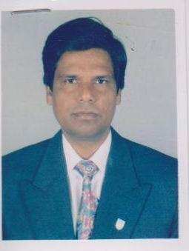 | DR. MD. LATIFUR RAHMAN  F/Name: Late Prof. Md Yusuf Ali  M/Name:  BM & DC Reg. No:  NID:  Cell:  Address: Bhata Para, Rajshahi  Blood Group:
81 | Voter No  LM-5500081  No Image | DR. MOSFIKA-ZEBARA-YEASMIN  F/Name: Mr. Abul - Quasem  M/Name:  BM & DC Reg. No:  NID:  Cell:  Address: 276, Padma- Housing Estate Road, No- 2 Bhadra, Rajshahi  Blood Group:
82 | Voter No  LM-5500082  No Image | DR. MD. ENAMUL HAQUE  F/Name: Md. Abul Hossain  M/Name:  BM & DC Reg. No:  NID:  Cell:  Address: Janata Clinic Laxmipur, Rajshahi DT., Rajshahi.  Blood Group:
83 | Voter No  LM-5500083  No Image | DR. SHAH AMANULLAH CHOUDHURY  F/Name: Late Alhaj Shah Azizul Hoque  M/Name:  BM & DC Reg. No:  NID:  Cell:  Address: 12/3, Sector-2, Housing Estate P.O.-Cantonment Rajshahi.  Blood Group:
84 | Voter No  LM-5500084  No Image | DR. SHAHELA ZESMIN  F/Name: Al Haz Shamsuddin Ahmed  M/Name:  BM & DC Reg. No:  NID:  Cell:  Address: 12/3, Sector-2, Housing Estate P.O.-Cantonment, Rahshahi.  Blood Group:
85 | Voter No  LM-5500085  No Image | DR. MD. MASUD ALI  F/Name: Late Dr Ak Mohammad Ali  M/Name:  BM & DC Reg. No: 21178  NID:  Cell:  Address: E-909, Kadirgonj, Boalia, Rajshahi.  Blood Group:
86 | Voter No  LM-5500086  No Image | DR. SHEIK MD. UDDIN  F/Name:  M/Name:  BM & DC Reg. No:  NID:  Cell:  Address: Lecturer, Micro Biology RMC, Rajshahi  Blood Group:
87 | Voter No  LM-5500087  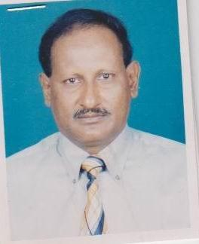 | DR. MD. JOHURUL ISLAM  F/Name: Late Md. Ahsan Ali  M/Name:  BM & DC Reg. No:  NID:  Cell:  Address: 44/45 Anawara Villa, Firajabad, Sopura, Rajshahi  Blood Group:
88 | Voter No  LM-5500088  No Image | DR. MD. BADIUZZAMAN  F/Name: Late Rustom Ali Mondol  M/Name:  BM & DC Reg. No:  NID:  Cell:  Address: Eye Department, Rajshahi Medical College, Rajshahi  Blood Group:
89 | Voter No  LM-5500089  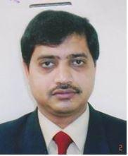 | DR. ALI HAIDER MD. TOHURUL ISLAM  F/Name: Md. Tofazzal Hossain  M/Name:  BM & DC Reg. No: 23420  NID:  Cell:  Address: Road # 06, House # 62, Padma Residential Area, Rajshahi  Blood Group:
90 | Voter No  LM-5500090  No Image | DR. FATEMA ASHRAF  F/Name: Mr. Munshi Nazib Uzzaman  M/Name:  BM & DC Reg. No:  NID:  Cell:  Address: Asstt. Prof. Dept, of Obs, & Gynae, RMCH, Rajshahi  Blood Group:
91 | Voter No  LM-5500091  No Image | DR. MD. AZIZUR RAHMAN JOARDER  F/Name: Late Munsur Ali Joarder  M/Name:  BM & DC Reg. No:  NID:  Cell:  Address: Shrmin Nursing Home, Laxmipur, Rajshahi  Blood Group:
92 | Voter No  LM-5500092  No Image | DR. SHIPRA CHAUDHURY  F/Name: Zaheerul Haq Chaudhury  M/Name:  BM & DC Reg. No:  NID:  Cell:  Address: Holding No 129 Kazihata, DB Office Lane ,Rajshahi  Blood Group:
93 | Voter No  LM-5500093  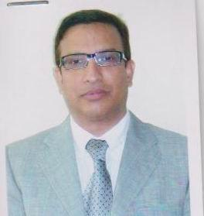 | DR. MD. RAIS. UDDIN MONDOL  F/Name: Dr. Md. Saif Uddin Mondol  M/Name:  BM & DC Reg. No:  NID:  Cell:  Address: Asstt. Prof. MCH, Rajshahi  Blood Group:
94 | Voter No  LM-5500094  No Image | DR. MD. AZIZUL HOQUE  F/Name: Late Sk Firuz Hussain  M/Name:  BM & DC Reg. No:  NID:  Cell:  Address: Laxmipur Vatapara, Rajshahi  Blood Group:
95 | Voter No  LM-5500095  No Image | DR. AHASAN HABIB  F/Name:  M/Name:  BM & DC Reg. No:  NID:  Cell:  Address: Associate Prof. Of Phycatry Rajshahi Medical College, Rajshahi  Blood Group:
96 | Voter No  LM-5500096  No Image | DR. A.K.M. SHAHIDUR RAHMAN  F/Name:  M/Name:  BM & DC Reg. No:  NID:  Cell:  Address: House #2/282, Housing State Flat # A-2, Upposhahar Rajshahi.  Blood Group:
97 | Voter No  LM-5500097  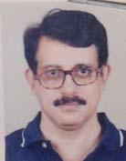 | DR. DEBASHISH ROY  F/Name: Nirmalendu Roy  M/Name: Rekha Roy  BM & DC Reg. No: 13636  NID: 8192220174588  Cell: 01712192104  Address: 128, Sultanabad, Ghoramara, Rajshahi-6000  Blood Group: A+
98 | Voter No  LM-5500098  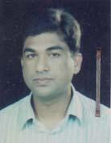 | DR. ABDULLAH AL MAMUN HOSSAIN  F/Name: Late Altaf Hussain  M/Name: Ms. Husne Ara Begum  BM & DC Reg. No: 16037  NID: 8194028198157  Cell: 01712554542  Address: DEPT. Of Psychiatry, Rajshahi Medical College, Rajshahi.  Blood Group: O+
99 | Voter No  LM-5500099  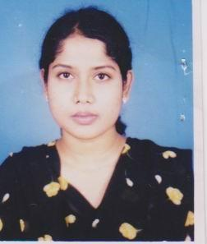 | DR. REZWANA SHARMI  F/Name: Dr Gotam Bagu Alam  M/Name: Dr. Shirina Sultana  BM & DC Reg. No:  NID:  Cell:  Address: Kumudini Womens Medical Collage Hospital, Mirzapur Tangail  Blood Group:
100 | Voter No  LM-5500100  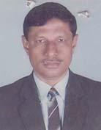 | DR. MD. ABUL FAZAL  F/Name: Late Sefatullah  M/Name: Late Ayesha Khatoon  BM & DC Reg. No: 8830  NID: 766875586012  Cell: 01711208096  Address: Aligonj, PO: Miapur, Rajshahi.  Blood Group: O+
101 | Voter No  LM-5500101  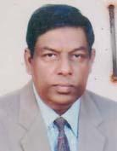 | DR. MD. SAIFUL ISLAM  F/Name: Late Md. Yeah-yea  M/Name: Begum Lutfun Nessa  BM & DC Reg. No: 6345  NID: 8123404601021  Cell: 01711816577  Address: 329/A Para Medical Road, Laxmipur, Rajshahi.  Blood Group: O+
102 | Voter No  LM-5500102  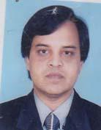 | DR. MD. ZULFIQUR ALI  F/Name: Late Dr. Abdus Samad  M/Name: Tahera Begum  BM & DC Reg. No: 23912  NID: 8192219329023  Cell: 01711578023  Address: Sheikh Mahal (2nd Floor), Professor Para, Chotabangram, Sapura, Rajshahi.  Blood Group: AB+
103 | Voter No  LM-5500103  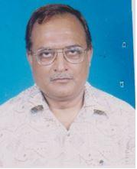 | DR. SAYED AHMED  F/Name: Md. Abdul Latif  M/Name: Wazeda Begum  BM & DC Reg. No: 12292  NID: 8192214343700  Cell: 01711200014  Address: House No: 168, 2nd Floor, Sector-3, Upz: Shaher, Rajshahi.  Blood Group: A+
104 | Voter No  LM-5500104  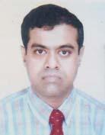 | DR. SHEIKH MUHAMMAD EKRAMULLAH  F/Name: Sheikh Abdur Rahim  M/Name: Rabeya Begum  BM & DC Reg. No: 16426  NID: 8198508260234  Cell: 01712646599  Address: Associate Professor, Dept. of Neurosurgery, Rajshahi Medical College, Rajshahi  Blood Group: A+
105 | Voter No  LM-5500105  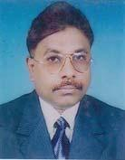 | DR. MD. IMDADUL HAQUE  F/Name: Late Md. Mohasin Ali  M/Name: Late Gedimoni  BM & DC Reg. No: 12792  NID: 8128208579332  Cell: 01711451066  Address: Asst. Prof. Department Of Paediatrics, Rajshahi Medical College.  Blood Group: O+
106 | Voter No  LM-5500106  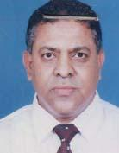 | PROF. (DR.) A. B. M. ABDUL HANNAN  F/Name:  M/Name:  BM & DC Reg. No: 9681  NID: 8192214344573  Cell: 01711839540  Address: Principal & Professor Of Surgery, Rajshahi Medical College.  Blood Group: O+  TRANSFERED to BMA Dhaka City  LM-1405543
107 | Voter No  LM-5500107  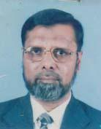 | DR. MD. MANZURUL HAQUE  F/Name: Md. Mozammel Haque  M/Name: Mrs. Amina Haque  BM & DC Reg. No: 7225  NID: 8198503432148  Cell: 01711815827  Address: Associate Professor (CC), Surgery, Rajshahi Medical College, Rajshahi-6000  Blood Group: A+
108 | Voter No  LM-5500108 | DR. MD. DURRUL HUDA  F/Name: Md. Toki Uddin  M/Name: Most. Shamsun Nahar  BM & DC Reg. No: 22483  NID: 8198505395221  Cell: 01715804433  Address: Deptt. Of Radiology & Imaging, Rajshahi Medical College Rajshahi .  Blood Group: O+
109 | Voter No  LM-5500109  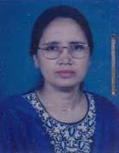 | DR. MEHERUNNESA  F/Name: Late M. Ismail  M/Name: Late Mrs. Jayeda Khatun  BM & DC Reg. No: 17001  NID: 8192214344614  Cell: 01713228358  Address: Junior Consultant (Pathology) OSD, DGHS Rajshahi Medical College.  Blood Group: O+
110 | Voter No  LM-5500110  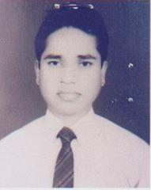 | DR. OBAIDUL HAQUE OBAI  F/Name: Md. Abdul Karim  M/Name: Mrs. Maleka Parvin Banu  BM & DC Reg. No: 27955  NID: 8192214345248  Cell: 01556303198  Address: H-24, Sec-2, Upashahar Housing Estate, P.O: Cantt-5202, Rajshahi.  Blood Group: B+
111 | Voter No  LM-5500111  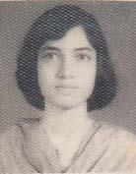 | DR. FAHMIDA SULTANA  F/Name: Md. Abul Kalam Azad  M/Name: Late Moslema Khatun  BM & DC Reg. No: 48226  NID: 819221829154  Cell: 01711013934  Address: House No: 4, Sector No: 2, Upshahar, Housing Estate, P.O.Cantt-5202, Rajshahi-6202.  Blood Group: B+
112 | Voter No  LM-5500112  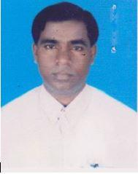 | DR. MD. MAFIZUL ISLAM  F/Name: Alhaj Md. Abdul Quddus  M/Name: Mst. Rabeya Begum  BM & DC Reg. No: 25345  NID: 8192210362805  Cell: 01720615183  Address: Vill; Hetem Kha, P.O: GPO-6000, P.S: Boalia, Dist: Rajshahi.  Blood Group: AB+
113 | Voter No  LM-5500113  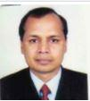 | DR. PROBODH KUMAR BISWAS  F/Name: Late Judhistir Chandra Biswas  M/Name:  BM & DC Reg. No:  NID:  Cell:  Address: T.F. Noagaon, LM-24  Blood Group:
114 | Voter No  LM-5500114  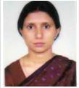 | DR. KABERI GUH  F/Name: Late Poresh Ch. Guh  M/Name:  BM & DC Reg. No:  NID:  Cell:  Address: N/A  Blood Group:
115 | Voter No  LM-5500115  No Image | DR. MD. SIDDIQUE HOSSAIN  F/Name:  M/Name:  BM & DC Reg. No:  NID:  Cell:  Address: a  Blood Group:
116 | Voter No  LM-5500116  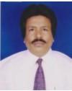 | DR. SHIRAJEE NAZMUL HASNAIN  F/Name: Late Giasuddin Shirajee  M/Name:  BM & DC Reg. No:  NID:  Cell:  Address: T.F. Chapai-Nawabgonj, LM-03  Blood Group:
117 | Voter No  LM-5500117 | DR. MD. GAZIUL ALAM  F/Name: Md. Gashir Uddin  M/Name: Late Latifa Begaum  BM & DC Reg. No: 12533  NID: 8198507221023  Cell: 01711483761  Address: B-64, Laxmipur, P.O: GPO-6000, Rajshahi.  Blood Group: A+
118 | Voter No  LM-5500118  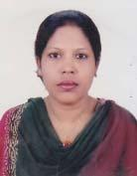 | DR. RAWSHAN ARA KHATUN  F/Name: Kazi Ahmed Jan  M/Name: Mst. Jobeda Khatun  BM & DC Reg. No: 21613  NID: 8198510364939  Cell: 01713228351  Address: M.O. MOPD, Rajshahi Medical College Hospital, Rajshahi.  Blood Group: A+
119 | Voter No  LM-5500119  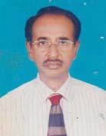 | DR. MOHD. ABDUR RAHMAN  F/Name: Mr. Mohi Uddin Ahmed  M/Name: Mrs. Rahima Begum  BM & DC Reg. No: 7879  NID: 8192226332916  Cell: 01712560614  Address: 269-2, Padma Residential Area, Rajshahi.  Blood Group: B+  E X P I R E D
120 | Voter No  LM-5500120  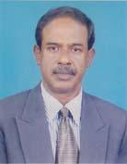 | DR. DIPAK KUMAR MOHANTA  F/Name: Sunil Kumar Mohanta  M/Name: Prova Rani Mohanta  BM & DC Reg. No: 11268  NID: 8198510362958  Cell: 01715519518  Address: Assistant. Prof, Pathology (C.C) Rajshahi Medical College.  Blood Group: B+
121 | Voter No  LM-5500121  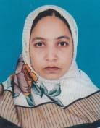 | DR. SAMIA NAZ  F/Name: Md. Badrul Kader  M/Name: Mst. Firoza Kader  BM & DC Reg. No: 19732  NID: 8192209251552  Cell: 01715056843  Address: D-206, Pathanpara, Rajshahi.  Blood Group: B+
122 | Voter No  LM-5500122  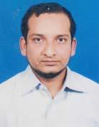 | DR. M. MORSED ZAMAN MIAH  F/Name: Md. Shohidul Alam  M/Name: Mist. Monowara Begum  BM & DC Reg. No: 37257  NID:  Cell: 01711814225  Address: Arundhoti, Kazihata, 2nd Floor, Rajshahi.  Blood Group: A+
123 | Voter No  LM-5500123  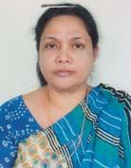 | DR. HASINA AKHTAR  F/Name: Panir Uddin Ahmed  M/Name: Nurjahan Begum  BM & DC Reg. No: 8297  NID: 8194030127408  Cell: 01711802450  Address: W14/B, Rajshahi University Campus Rajshahi.  Blood Group: B+
124 | Voter No  LM-5500124  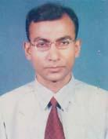 | DR. MD. SHARIF CHOWDHURY  F/Name: Chowdhury Md. Ilias  M/Name: Late Sahera Banu  BM & DC Reg. No: 26916  NID: 2697557397376  Cell: 01712618510  Address: Department Of Radiology & Imaging, Rajshahi Medical College Hospital Rajshahi  Blood Group: O+
125 | Voter No  LM-5500125  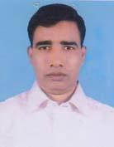 | DR. MD. ABDUL BARI  F/Name: Md. Nasiruddin  M/Name: Fatema Begum  BM & DC Reg. No: 29028  NID: 2696352218153  Cell: 01716385474  Address: 259/2, Padma R/A Boalia, Rajshahi.  Blood Group: B+
126 | Voter No  LM-5500126  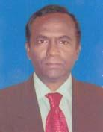 | DR. BIMAL KUMAR BASU  F/Name: Late. Bipul Chandra Basu  M/Name: Late Shipra Rani Basu  BM & DC Reg. No: 16067  NID: 8198506401184  Cell: 01711108374  Address: 192, B, Kazihata Rajshahi-6000.  Blood Group: B+
127 | Voter No  LM-5500127  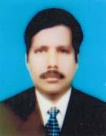 | DR. MD. NOWSHAD ALI  F/Name: Late Eyad Ali Mandal  M/Name: Mst. Champa Begum  BM & DC Reg. No: 23050  NID: 8118213536028  Cell: 01711123748  Address: Asst. Prof. ( Pedi. Surgery), Rajshahi Medical College.  Blood Group: AB+
128 | Voter No  LM-5500128  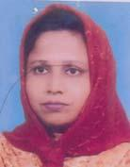 | DR. KHADIZA KHANAM  F/Name: Late Abdul Aziz Sikder  M/Name: Aleya Begum  BM & DC Reg. No: 25341  NID: 8192212234462  Cell: 01713228367  Address: Department Of Pathology Rajshahi Medical College.  Blood Group: O+
129 | Voter No  LM-5500129  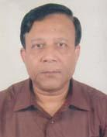 | DR. A.K.M. MONOARUL ISLAM  F/Name: Md. Abul Kalam Azad  M/Name: Monowara Begum  BM & DC Reg. No: 12810  NID: 8198510364938  Cell: 01713228350  Address: Associate Professor, Nephrology Rajshahi Medical College, Rajshahi.  Blood Group: B+
130 | Voter No  LM-5500130 | DR. MD. HAFIZUR RAHMAN  F/Name: Md. Mozaher Ali Pramanic  M/Name: Most. Mazeda Khatun  BM & DC Reg. No: 20925  NID: 8198510364179  Cell: 01714475325  Address: 528/1, Kazihata Rajshahi, GPO Rajshahi-6000.  Blood Group: B+
131 | Voter No  LM-5500131  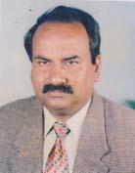 | DR. MD. MONSUR RAHMAN  F/Name: Late Abdur Rahman Mondal  M/Name: Late Fatema Khatun  BM & DC Reg. No: 9185  NID: 8113159511212  Cell: 01711895387  Address: Holding-282, G-777, Sultanabad, Ghoramara, Rajshahi.  Blood Group: B+
132 | Voter No  LM-5500132  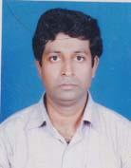 | DR. SUBRATA GHOSH  F/Name: Subhash Chandra Ghosh  M/Name: Joyanti Ghosh  BM & DC Reg. No: 34257  NID: 8192222318147  Cell: 01712025871  Address: 327/ Sagarpara, Ghoramara, Rajshahi.  Blood Group: B+
133 | Voter No  LM-5500133  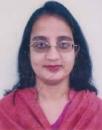 | DR. NUR-A-ATIA LOVELY  F/Name: Md. Anwar Ali  M/Name: Mrs. Shawkat Ara Begum  BM & DC Reg. No: 35784  NID: 8132226330614  Cell: 01814967747  Address: Lecturer, Dept. Of Biochemistry, Rajshahi Medical College.  Blood Group: B+
134 | Voter No  LM-5500134  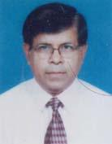 | DR. MD. ABU BAKAR SIDDIQUE  F/Name: Md. Ibrahim Hossain  M/Name: Zomila Khatun  BM & DC Reg. No: 8507  NID: 8192225179206  Cell: 01713228376  Address: Senior Consultant, Surgery, Adhunik Sadar, Hospital, Natore.  Blood Group: A+
135 | Voter No  LM-5500135  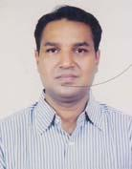 | DR. MD. AZIZUL HAQUE  F/Name: Md. Fazlul Haque  M/Name: Suraiya Haque  BM & DC Reg. No: 27620  NID: 8198505391080  Cell: 01715367844  Address: Flat 4/A, Suvechcha Nibas, Chandipur, Rajshahi.  Blood Group: B+
136 | Voter No  LM-5500136  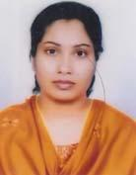 | DR. LAILA SHAMIMA SHARMIN  F/Name: Md. Rabiul Alam  M/Name: Jahanara Khatun  BM & DC Reg. No: 33835  NID: 8198505391081  Cell: 01712299174  Address: Flat 4/A, Suvechcha Nibas, Chandipur, Rajshahi.  Blood Group: O+
137 | Voter No  LM-5500137  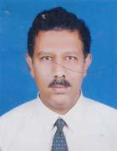 | DR. MD. RUHUL AMIN  F/Name: Md. Athar Hossain  M/Name: Most. Rabeya Hossain  BM & DC Reg. No: 20355  NID: 19668192218000003  Cell: 01942336430  Address: Area -46/Shalbagan, P.O; Sopura code-6203, Dist: Rajshahi.  Blood Group: B+
138 | Voter No  LM-5500138 | DR. NASIM AKHTER ARINA  F/Name: Md. Abdul Mannan  M/Name: Mrs. Razia Mannan  BM & DC Reg. No: 24019  NID: 8192221355344  Cell: 01711302340  Address: MCWC, Hatem Khan, Rajshahi.  Blood Group: O+
139 | Voter No  LM-5500139  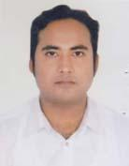 | DR. MD. RAJIUL HAQUE  F/Name: Prof. Md. Habibullah Mia  M/Name: Khursheda Khanom  BM & DC Reg. No: 50923  NID: 8192213100809  Cell: 01711302127  Address: Hamim Villa, Hold No:180, East Of Eid Gah, Kadirgonj, P.O: GPO: 6000, Boalia, Rajshahi.  Blood Group: A+
140 | Voter No  LM-5500140  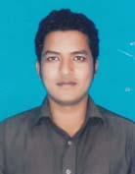 | DR. DEWAN MD MEHEDI HASAN  F/Name:  M/Name:  BM & DC Reg. No: 50374  NID: 8193510365066  Cell: 01717515166  Address: 157/3, Housing State, Uposhohor, Rajshahi-6203.  Blood Group: O+  TRANSFERED to BMA Dhaka City  LM-1405543
141 | Voter No  LM-5500141  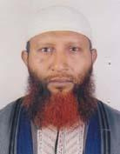 | DR. MD. ASADUR RAHMAN  F/Name: Md. Anisur Rahman  M/Name: Shakhina Begum  BM & DC Reg. No: 20659  NID: 8198508263126  Cell: 01915342209  Address: 52, Kazihata C& B Mor Rajshahi.  Blood Group: A+
142 | Voter No  LM-5500142  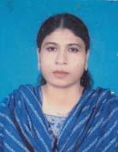 | DR. MST. ROKEYA KHATUN  F/Name: Late Osman Mollah  M/Name: Mst. Sonavan Begum  BM & DC Reg. No: 25549  NID: 8118213635045  Cell: 01712803053  Address: Consultant, ( G & O) Dept Of G& Obst, Rajshahi Medical College Hospital.  Blood Group: A+
143 | Voter No  LM-5500143 | DR. MOHAMMAD MAHBUBUR RAHMAN KHAN  F/Name: Mohammad Khan Eshahaque Ali  M/Name: Khairun Nahar Khanam  BM & DC Reg. No: 19910  NID: 8192218296687  Cell: 01711302263  Address: Assistant Prof. ( Medicine) Rajshahi Medical College.  Blood Group: AB+
144 | Voter No  LM-5500144  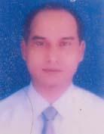 | DR. MD. MATIUL ISLAM  F/Name: Late Abdul Mozid Miah  M/Name: Mrs. Komela Begum  BM & DC Reg. No: 27549  NID: 3219150558282  Cell: 01713210203  Address: House No: 11, Ward No: 18, Salbagan, Sopura, Boalia, Rajshahi.  Blood Group: A+
145 | Voter No  LM-5500145  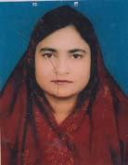 | DR. SHAMIMA KHATUN  F/Name: Late Sakender Ali  M/Name: Mrs. Sumsun Nahar  BM & DC Reg. No: 33739  NID: 8192218297233  Cell: 01711390398  Address: House No: 11, Ward NO: 18, Salbagan, Sopura, Boalia, Rajshahi.  Blood Group: O+
146 | Voter No  LM-5500146  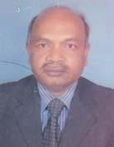 | DR. MD. KHALILUR RAHMAN  F/Name: Late Meher Ali Sarker  M/Name: Anwara Begum  BM & DC Reg. No: 20590  NID: 8192212234463  Cell: 01711302261  Address: Department Of Medicine, Rajshahi Medical College Rajshahi.  Blood Group: B+
147 | Voter No  LM-5500147  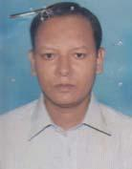 | DR. MD. ABU SAYEM  F/Name: Md. Abu Bokor Siddik  M/Name: Mrs. Marium Begum  BM & DC Reg. No: 42402  NID: 8515854896465  Cell: 01712779808  Address: Director ( Health), Rajshahi, (Division Consultant- Rajshahi, NTP, DGHS)  Blood Group: A+
148 | Voter No  LM-5500148  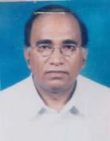 | DR. MD. TOWFIQUL ISLAM  F/Name: Late. Shahjaman Mia  M/Name: Towfiqun Nessa  BM & DC Reg. No: 8932  NID: 8192222428093  Cell: 01711483693  Address: Deputy Director, Office Of The Director (Health), Rajshai Div. Raj.  Blood Group: A+
149 | Voter No  LM-5500149  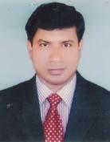 | DR. MD. ANISUR RAHMAN  F/Name: Md. Anowar Hossain Sarker  M/Name: Most. Shamsunnahar Begum  BM & DC Reg. No: 32298  NID: 6914447527239  Cell: 01712839547  Address: 663/1, Uposhohor Housing Estate, P.O; Sopura, P.S: Boalia, Rajshahi.  Blood Group: B+
150 | Voter No  LM-5500150  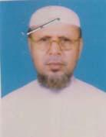 | DR. MD. MOJIBUR RAHMAN  F/Name: Late. Naimuddin Mondal  M/Name: Late Tilojan Nessa  BM & DC Reg. No: 8790  NID: 8198506409015  Cell: 01715002365  Address: 813/Baganpara, Lakshmipur, Rajshahi.  Blood Group: B+
151 | Voter No  LM-5500151  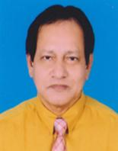 | PROFESSOR DR. MD. BELAL UDDIN  F/Name: Late Md. Mobarak Hossain  M/Name: Most. Saera Khatun  BM & DC Reg. No: 18554  NID: 8198506400040  Cell: 01711013743  Address: Professor of Pediatrics, Rajshahi Medical College, Rajshahi  Blood Group: O+
152 | Voter No  LM-5500152  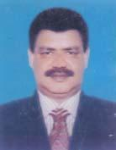 | DR. MD. MOHIBUL HASSAN  F/Name: Late Abu Ahmed Abdul Latif  M/Name: Begum Meherun Nessa  BM & DC Reg. No: 42856  NID: 8192214344485  Cell: 01713228346  Address: Asst. Prof. Dept. Of Surgery, Shaheed Ziaur Rahman Medical College, Bogra.  Blood Group: AB+
153 | Voter No  LM-5500153  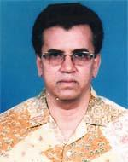 | DR. WALI AHMED  F/Name: Mohd. Sadeque Ali Mondal  M/Name: Most. Rabeya Khatun  BM & DC Reg. No: 13590  NID: 19598198505398447  Cell: 01711467327  Address: Mourusi 29/A, Ward-10, Ghosh Para, Rajshahi city, Rajshahi  Blood Group: O+
154 | Voter No  LM-5500154  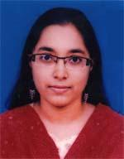 | DR. FARJANA KABIR  F/Name: Enamul Kabir  M/Name: Rahima Begum  BM & DC Reg. No: 49617  NID: 8192222429004  Cell: 01731845534  Address: Physiology Department , Rajshahi Medical College Rajshahi  Blood Group: B+
155 | Voter No  LM-5500155  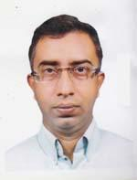 | DR. KHANDKER MD. FAISAL ALAM  F/Name: Late Khandker Shamsul Alam  M/Name: Late Alema Sharifa  BM & DC Reg. No: 23518  NID: 8198508260156  Cell: 01739030974  Address: Shekor Hovsf:492, Kazihata, Rajshahi-6000  Blood Group: O+
156 | Voter No  LM-5500156  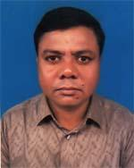 | DR. PRABIR MOHAN BASAK  F/Name: Sankar Mohan Basak  M/Name: Saptomi Rani Basak  BM & DC Reg. No: 34135  NID: 2697557397816  Cell: 01712416862  Address: W-161, Medicient Dept. Rajshahi Medical College Hospital, Rajshahi-6000  Blood Group: O+
157 | Voter No  LM-5500157  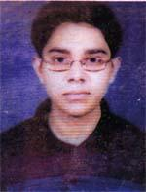 | DR. MD. NASIB UJ ZAMAN  F/Name: Md. Surat Zaman  M/Name: Nasrin Akhter  BM & DC Reg. No: 60843  NID: 01988819850539217  Cell: 01724308676  Address: 490 (H.N) , Raninagar, Ghoramara, Boalia Thana, Rajshahi  Blood Group: AB+
158 | Voter No  LM-5500158  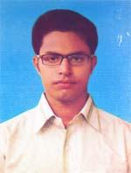 | DR. MD. SHAFIQUL ISLAM OPU  F/Name: Md. Abdul Mannan  M/Name: Rabya Khatun  BM & DC Reg. No: 77026  NID: 19926125207000079  Cell: 01745222655  Address: Room No. 104, Shahid Sha Moinul Ahsan Hostel, Rajshahi.  Blood Group: O+
159 | Voter No  LM-5500159  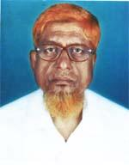 | DR. MD. ALI NAOROZ  F/Name: Late Md. Mowiuddin  M/Name: Late Halima Khatun  BM & DC Reg. No: 9860  NID: 8192215245685  Cell: 01714020050  Address: Kadirgong, Darikhorbona, House No. 421/B, Cantonment 6202, Rajshahi  Blood Group: O+
160 | Voter No  LM-5500160  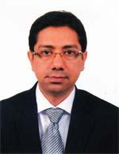 | DR. AHMED ASIF IQBAL  F/Name: Ansar Uddin Ahmed  M/Name: Husney Ara Begum  BM & DC Reg. No: 26728  NID: 8192222316652  Cell: 01718280538  Address: Asst. Prof. Ortho Surgery Department, RMCH, H-353, Suniket, Ghoranmara, Bolia, Rajshahi  Blood Group: O+
161 | Voter No  LM-5500161  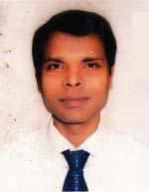 | DR. MD. NURE ALOM SIDDIQUI  F/Name: Md. Enamul Hoqui  M/Name: Most. Hamida Begum  BM & DC Reg. No: 28984  NID: 8198503434821  Cell: 01712213110  Address: Asst. Prof. Medicine Dep. RMCH  Blood Group: O+
162 | Voter No  LM-5500162  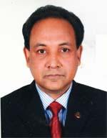 | DR. MOHD. ALAMGIR HOSSAIN  F/Name: Mohd. Abed Ali Biswas  M/Name: Dil Rawshan  BM & DC Reg. No: 21513  NID: 8192225359963  Cell: 01712511462  Address: Associate Professor(Ortho-Surgery), Rajshahi Medical College, Rajshahi  Blood Group: O+
163 | Voter No  LM-5500163  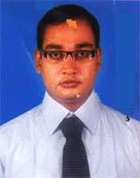 | DR. MD. TAMJID ALI  F/Name: Prof. Amjad Ali  M/Name: Rowshan Ara Begum  BM & DC Reg. No: 43209  NID: 2697557395492  Cell: 01678150705  Address: OSD, DGHS, Mohakhali, Dhaka-1212, Deputed To MD. (Residency), Physical Medicine & Rehabilitation, BSMMU  Blood Group: O+
164 | Voter No  LM-5500164  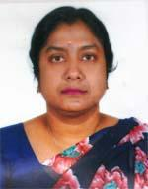 | DR. MOSAMMAT NARGIS SHAMIMA  F/Name: Md. Asaduzzaman  M/Name: Hasina Begum  BM & DC Reg. No: 21021  NID:  Cell: 01716402819  Address: Assistant Professor (Gynee), Rajshahi Medical College, Rajshahi  Blood Group: O-
165 | Voter No  LM-5500165 | DR. BOLAI CHONDRO SARKER  F/Name: Gonesh Chondro Sarker  M/Name: Usha Rani Sarker  BM & DC Reg. No: 35631  NID: 8112539891505  Cell: 01712105766  Address: Jhaotola More, Laxmipur, Rajshahi  Blood Group: O+
166 | Voter No  LM-5500166  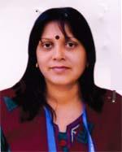 | DR. RAKHI DEBI  F/Name: Late Sujit Kumar Debnath  M/Name: Anima Debi  BM & DC Reg. No: 35632  NID: 8112539891506  Cell: 01718788166  Address: Jhaotola More, Laxmipur, Rajshahi  Blood Group: O+
167 | Voter No  LM-5500167  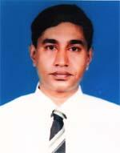 | DR. ABU HENA MOSTAFA KAMAL  F/Name: Mir Mahmudul Haque  M/Name: Most. Khodeza Begum  BM & DC Reg. No: 24862  NID: 19688198503432430  Cell: 01711135497  Address: ARC South Breeze, 2nd Floor. Stadium Road, New Bilshimla, Rajshahi  Blood Group: B+
168 | Voter No  LM-5500168  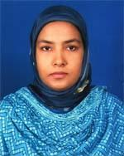 | DR. WAHIDA KHATUN  F/Name: M. Tojammel Hossain  M/Name: Most. Johora Khatun  BM & DC Reg. No: 28233  NID: 19748198503432429  Cell: 01746725605  Address: ARC South Breep, 2nd Floor, Stadium Road, New Polshimla, Rajshahi  Blood Group: B+
169 | Voter No  LM-5500169  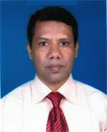 | DR. MD. JAWADUL HAQUE  F/Name: Md. Esarul Haque  M/Name: Marium Begum  BM & DC Reg. No: 14487  NID: 8192214345204  Cell: 01713228327  Address: Prof. & Head , Dept. of Community Medicines, Rajshahi Medical College, Rajshahi  Blood Group: O+
170 | Voter No  LM-5500170  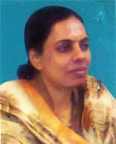 | DR. SHERMIN SALINA SULTANA  F/Name: Late Lutfor Rahman  M/Name: Late Monowara Begum  BM & DC Reg. No: 19909  NID: 8198503438955  Cell: 01711318489  Address: Mo, Fwuti, Rajshahi  Blood Group: O+
171 | Voter No  LM-5500171  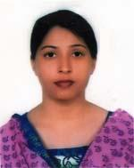 | DR. RUPSHA NURA LAILA  F/Name: Md. Emdadul Haque  M/Name: Mrs. Monowara Begum  BM & DC Reg. No: 36258  NID: 8198510364488  Cell: 01715204738  Address: Santu Cottage , Holding No. 213, T.B. Road, Laxmipur, Rajshahi  Blood Group: O+
172 | Voter No  LM-5500172  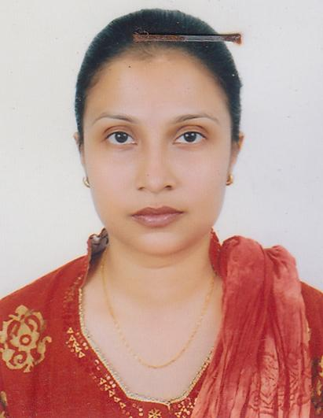 | DR. MD. SHOHIDUL ISLAM  F/Name: Late Mocklechar Rahman  M/Name: Mrs. Safura Khatun  BM & DC Reg. No: 34914  NID: 8198506401424  Cell: 01818735801  Address: 313/A Kazihata, Rajshahi  Blood Group: B+
173 | Voter No  LM-5500173  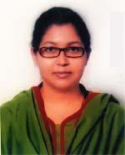 | DR. SHAHANAZ BANU  F/Name: Let. Md. Emdadul Haque  M/Name: Mrst. Monowara Begum  BM & DC Reg. No: 33297  NID: 8198506402367  Cell: 01718172271  Address: Santu Cottage Laxmipur, T. B. Hospital Road, Rajpara Gpo-6000, Rajshahi  Blood Group: O+
174 | Voter No  LM-5500174  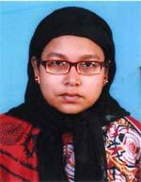 | DR. MST. AFROZA KHATUN  F/Name: Md. Aminul Huq  M/Name: Mrs. Morium Begum  BM & DC Reg. No: 21025  NID: 6924103058860  Cell: 01711129769  Address: Shibganj, Chapainawabgonj  Blood Group: A+
175 | Voter No  LM-5500175  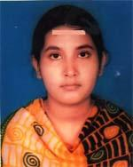 | DR. NASRIN AKTER  F/Name: Md. Shajahan Mia  M/Name: Shamsun Nahar  BM & DC Reg. No: 45898  NID: 6725803911799  Cell: 01717450743  Address: 88/A Helenabad Girls School Road Vatapara, Rajshahi  Blood Group: B+
176 | Voter No  LM-5500176  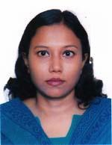 | DR. FAHMIDA SHIREEN NEELA  F/Name: Md. Mokhlesur Rahman  M/Name: Mrs. Tanjila Rahman  BM & DC Reg. No: 31153  NID: 19758192214345249  Cell: 01712204590  Address: House No. 24, Sector 2, Road 2, Upashahar Housing Estate, Rajshahi  Blood Group: O+
177 | Voter No  LM-5500177  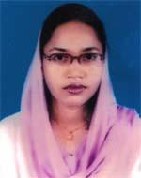 | DR. MST. MOSFIKA KOWSARI  F/Name: Md. Golam Mostafa  M/Name: Mst. Mojtahedun Nesa  BM & DC Reg. No: 43596  NID: 2696829754862  Cell: 01712945518  Address: 360, Konika, New Bil Shimla, Rajshahi-6000  Blood Group: O+
178 | Voter No  LM-5500178  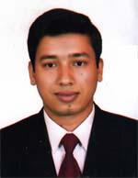 | DR. BIDHAN KUMAR FOWJDAR  F/Name: Priyanath Fowjdar  M/Name: Sushama Fowjdar  BM & DC Reg. No: 37980  NID: 8128205574743  Cell: 01712503197  Address: Anaesthemia & ICU Dept. Rajshahi Medical College Hospital, Rajshahi  Blood Group: AB+
179 | Voter No  LM-5500179  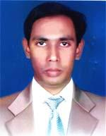 | DR. SUBAL CHANDRA PAUL  F/Name: Late Naresh Chandra Paul  M/Name: Late Basanti Rani Paul  BM & DC Reg. No: 34781  NID: 7214023490154  Cell: 01712051950  Address: 519 Kazihata, Rajshahi-6000  Blood Group: O+
180 | Voter No  LM-5500180  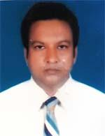 | DR. MD. RANA MAHFUZUL HAQUE  F/Name: Md. Abdul Haque  M/Name: Mahfuza Khatun  BM & DC Reg. No: 22717  NID: 8192209252327  Cell: 01711968699  Address: 246, Pathanpara , Rajshahi  Blood Group: B+
181 | Voter No  LM-5500181  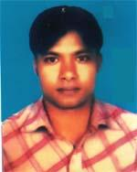 | DR. MD. AMINUL ISLAM  F/Name: Md. Anwar Hossain  M/Name: Most. Hazera Khatun  BM & DC Reg. No: 44496  NID: 19826914181000025  Cell: 01716024266  Address: Mo. Upazilla Health Complex, Charghat, Rajshahi  Blood Group: O+
182 | Voter No  LM-5500182  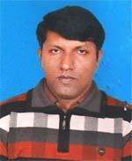 | DR. MD. ARIFUL ALAM SUMON  F/Name: Md. Rustam Ali Mondal  M/Name: Mrs. Afroza Shahin  BM & DC Reg. No: 39810  NID: 8192222352762  Cell: 01924030949  Address: 217/2, Poba, Notun Para, Post-Sopvra, Rajshahi  Blood Group: A+
183 | Voter No  LM-5500183  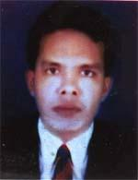 | DR. MD. FAISHAL SHAHNEWAZ HAQUE  F/Name: Dr. Md. Enamul Haque  M/Name: Mrs. Fikria Haque  BM & DC Reg. No: 47488  NID: 8192214344046  Cell: 01712114522  Address: Janata Clinic, Hatem Kha, Rajshahi, Thana-Boalia, Rajshahi  Blood Group: O+
184 | Voter No  LM-5500184  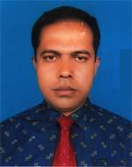 | DR. MD. HABIBUL HASAN  F/Name: Late Md. Jamal Uddin Ahmed  M/Name: Hasna Banu  BM & DC Reg. No: 42433  NID: 8192214344012  Cell: 01717544883  Address: C-34, Sopjra, Bscic Industrial Area, 6202, Rajshahi  Blood Group: AB+
185 | Voter No  LM-5500185  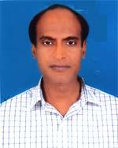 | DR. MD. ARSHED ALI  F/Name: Md. Abdul Kashem  M/Name: Mrs. Asia Khatun  BM & DC Reg. No: 38862  NID: 4798516214925  Cell: 01716414380  Address: Surgery Department, RMCH  Blood Group: A+
186 | Voter No  LM-5500186  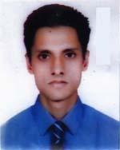 | DR. MD. ABDULLAHIL BAKI  F/Name: Md. Abdur Razzaque  M/Name: Tahsina Ferdous  BM & DC Reg. No: 60587  NID: 8192226330620  Cell: 01922522807  Address: House -188, Road-4, Padma Residential Area, P.s-Bualia, Rajshahi  Blood Group: O+
187 | Voter No  LM-5500187  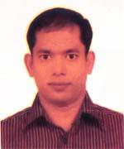 | DR. MD. SHAHIDUL ISLAM ROBIN  F/Name: Md. Ismail Hossain  M/Name: Mrs. Nurjahan Begum  BM & DC Reg. No: 45857  NID: 8524904189559  Cell: 01712198269  Address: Upazilla Health Complex, Tarone, Rajshahi  Blood Group: O+
188 | Voter No  LM-5500188  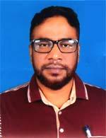 | DR. A. K. M. NURUL AMIN  F/Name: Late Atahar Ali Khan  M/Name: Most. Achia Khatun  BM & DC Reg. No: 32243  NID: 19728198506000001  Cell: 01746013258  Address: 356, Shersah Road, Laxmipur, Rajshahi-6000  Blood Group: AB+
189 | Voter No  LM-5500189  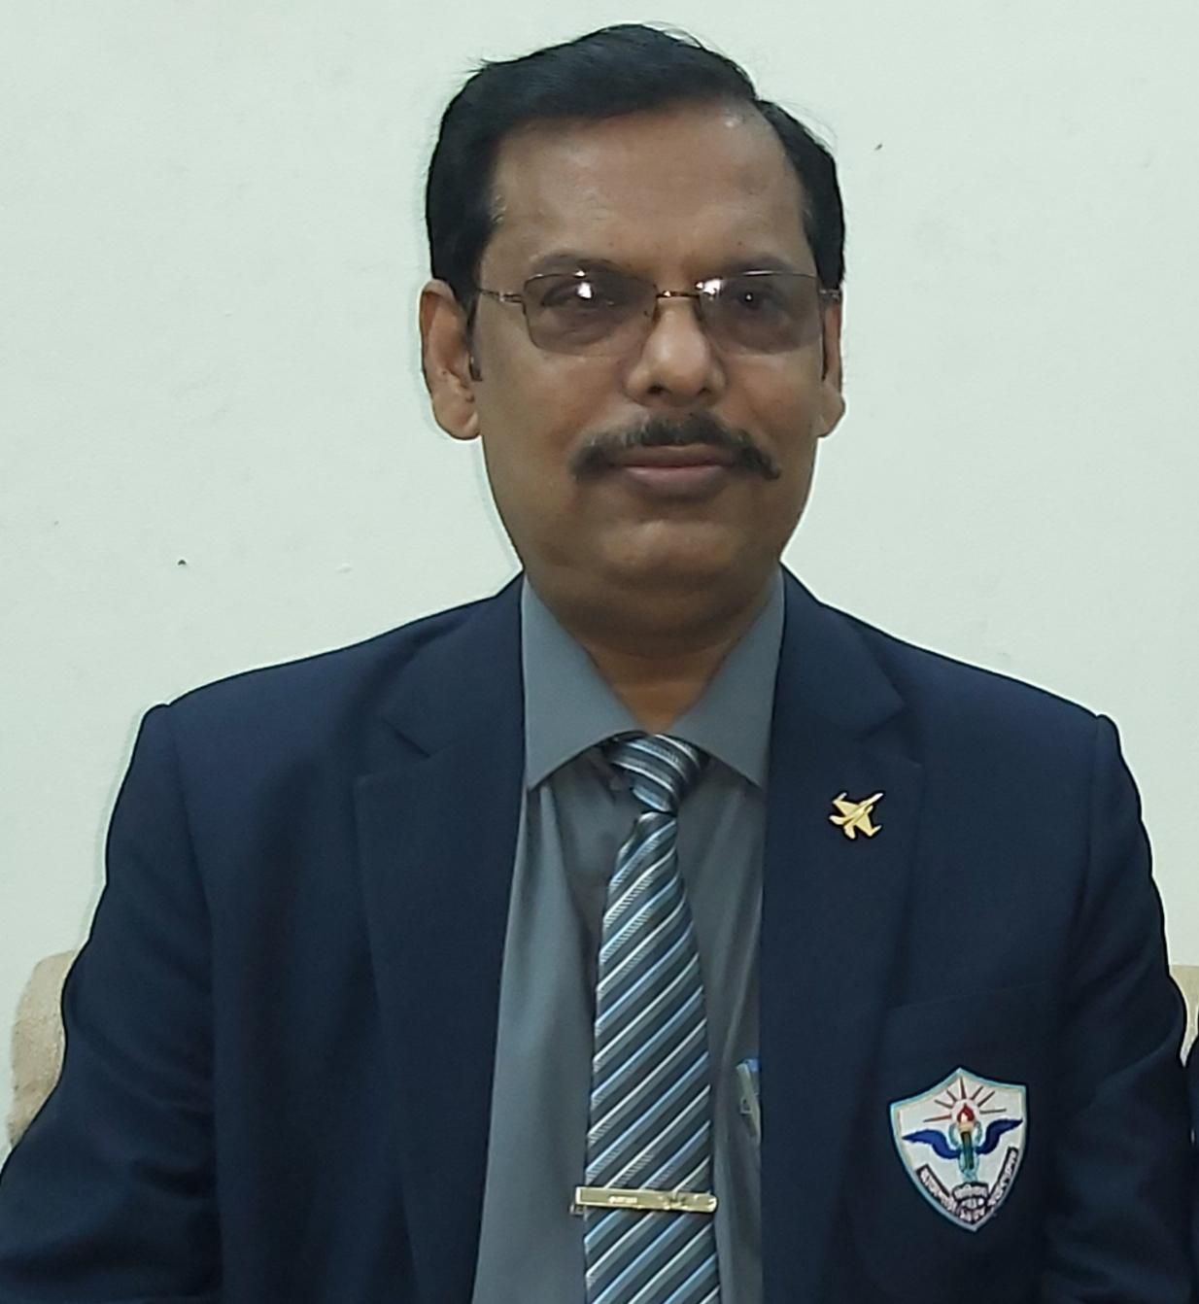 | DR. MD. SELIM KHAN  F/Name: Late Afzal Hossain Khan  M/Name: Mst. Asma Khan  BM & DC Reg. No: 21024  NID: 19666924103058859  Cell: 01713228383  Address: Rajshahi Medical College  Blood Group: O+
190 | Voter No  LM-5500190  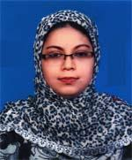 | DR. SOME ROSE PERVIN  F/Name: Md. Mohasin Ali  M/Name: Rowshan Ara Begum  BM & DC Reg. No: 45788  NID: 2691650160778  Cell: 01791111460  Address: 262/3, pathanpara, Rajshahi  Blood Group: O+
191 | Voter No  LM-5500191  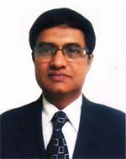 | DR. SUZON AL HASAN  F/Name: Md. Ashraff Hossain  M/Name: Roushan Begum  BM & DC Reg. No: 16925  NID: 1595715413543  Cell: 01819349500  Address: 111 Bihas, Choddopai Binodpur, Rajshahi  Blood Group: B+
192 | Voter No  LM-5500192  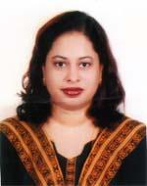 | DR. MUHATARIMA TABASSUM  F/Name: Md. Shahidur Rahman  M/Name: Shirin Rahman  BM & DC Reg. No: 40191  NID: 8194030122661  Cell: 01712639303  Address: 111 Bihas, Choddopai, Binodpur, Rajshahi  Blood Group: AB+
193 | Voter No  LM-5500193  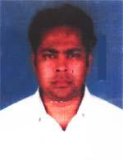 | DR. MD. MANIRUL HAQUE FARNFDER  F/Name: Md. Mahmudul Haque Farfder  M/Name: Mrs. Rahima Khatun  BM & DC Reg. No: 36647  NID: 8198506402816  Cell: 01720176888  Address: 236, IB Road Laxmipur, Rajshahi  Blood Group: A+
194 | Voter No  LM-5500194  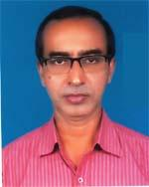 | DR. NISITH KUMAR MAJUMDER  F/Name: Mr. Nirmalendu Majumder  M/Name: Mrs. Komola Majumder  BM & DC Reg. No: 18197  NID: 7623902505487  Cell: 01712247751  Address: Wd-32, Cardiology Unit, Rajshahi Medical College Hospital Rajshahi.  Blood Group: AB+
195 | Voter No  LM-5500195  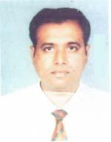 | DR. MONISHANKOR ROY  F/Name: Abani Kumar Roy  M/Name: Dipaliroy  BM & DC Reg. No: 34912  NID: 2691650162194  Cell: 01712061915  Address: Shandha nir, House No. 41, Ghoramar, Boalia, Rajshahi  Blood Group: A+
196 | Voter No  LM-5500196  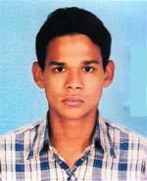 | DR. MD. SHAHIDULLAH  F/Name: Md. Bokhtiar Hossain  M/Name: Rumali Begum  BM & DC Reg. No: 66441  NID: 7016619361725  Cell: 01717639231  Address: Vill+Post-Baraghoria, Thana+Dist-Chapai Nawabganj  Blood Group: O+
197 | Voter No  LM-5500197  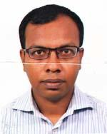 | DR. A. F. M. MOMTAZUL HAQUE  F/Name: Md. Shamsur Ali Sana  M/Name: Momtaz Nahar  BM & DC Reg. No: 32045  NID: 2696402507722  Cell: 01819406068  Address: Ward # 8, Dept. of Neurology Sergery, Rajshahi Medical College  Blood Group: B+
198 | Voter No  LM-5500198  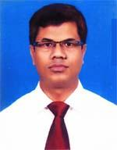 | DR. SARDER BELAL HOSSAIN  F/Name: Md. Abdur Rahman  M/Name: Mrs. Rabeya Begum  BM & DC Reg. No: 34693  NID: 6414754867637  Cell: 01819132228  Address: Upazilla Health Complex, Bagmara, Rajshahi  Blood Group: B+
199 | Voter No  LM-5500199  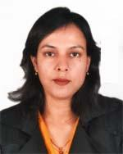 | DR. KHAN ISHRAT JAHAN  F/Name: Abdul Aziz Khan  M/Name: Monowara Khan  BM & DC Reg. No: 33784  NID: 8192218295623  Cell: 01716068234  Address: H-18, Asam Colony, Post-Sopura 6203, Boalia, Rajshahi  Blood Group: AB+
200 | Voter No  LM-5500200  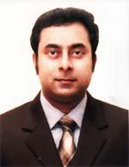 | DR. MD. ABUL EHSAN  F/Name: Md. Abdullah Al Mamun  M/Name: Most. Seleena Sultana  BM & DC Reg. No: 49500  NID: 8192213104724  Cell: 01740602828  Address: Kisholoy 275-G, Sasthitola, G.P.O.-6000, Boalia, Rajshahi  Blood Group: A+
201 | Voter No  LM-5500201  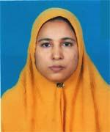 | DR. MONOWARA BEGUM  F/Name: Md. Ansar Ali  M/Name: Khaleda Begum  BM & DC Reg. No: 32676  NID: 8198510364970  Cell: 01740941412  Address: Consultant (Gynee), Rajshahi Medical College Hospital, Rajshahi  Blood Group: A+
202 | Voter No  LM-5500202  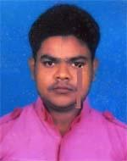 | DR. MD. NAZMUL HOSSAIN HUDA  F/Name: Md. Abdul Kader Prang  M/Name: Nazma Khatn  BM & DC Reg. No: 77506  NID: 19927618317000318  Cell: 01727360433  Address: Shaheed Muktizoddha Kazi Nurrunnabi Hostel Room-202 Rajshahi.  Blood Group: A+
203 | Voter No  LM-5500203  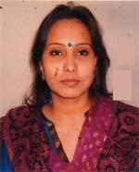 | FARIDA YEASMEN MOONMOON  F/Name: Gazi Md. Solaimar  M/Name: Mrs. Masuma Khatun  BM & DC Reg. No: 53589  NID: 8524904042174  Cell: 01843889860  Address: 99, Swapnil Vaban, Kadirganj, Rajshahi-6000  Blood Group: A+
204 | Voter No  LM-5500204  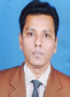 | DR. M.SHARIF UDDIN  F/Name: Md.ayn Uddin  M/Name: Mst.monoara Begum  BM & DC Reg. No: A46378  NID: 819850898178  Cell: +88 01712247657  Address: Holding -127, Luxmipur TB Road Rajpara.Rajshahi.  Blood Group: AB+
205 | Voter No  LM-5500205  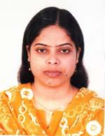 | DR. MST. NILUFA YASMIN  F/Name: Md. Nasir Uddin  M/Name: Mstt. Morium Khatun  BM & DC Reg. No: 67293  NID: 8524904042585  Cell: 01736750244  Address: Musafir Mahal, Holding No. 255, Shahebpara, Luxmipur Kachabazar, GPO-6000, Rajpara, Rajshahi  Blood Group: B+
206 | Voter No  LM-5500206  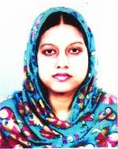 | DR. SHAHANA PARVIN  F/Name: Md. Mosarraf Hossain  M/Name: Manwar Sultana  BM & DC Reg. No: 46379  NID: 8198508981788  Cell: 01790839260  Address: House No. 127, Luxmipur TB Road, Rajpara, Rajshahi-6000  Blood Group: O+
207 | Voter No  LM-5500207  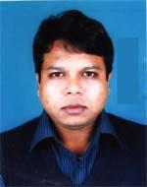 | DR. MOHAMMAD ALI CHOWDHURY  F/Name: Md. Abdur Rauf Chowdhury  M/Name: Most. Mohosina Begum  BM & DC Reg. No: 45416  NID: 8198508262173  Cell: 01715409870  Address: 178/6, Road-2, Chondvima R/A, Boalia, New Town Vodra, Rajshahi-6207  Blood Group: B+
208 | Voter No  LM-5500208  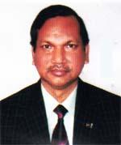 | DR. MD. ENAMUL HOQUE  F/Name: Md. Shamsul Hoque  M/Name: Mst. Amina Khatun  BM & DC Reg. No: 11742  NID:  Cell: 0171328340  Address: House # 301, Road # 02, Padma R/A Rajshahi  Blood Group: O+
209 | Voter No  LM-5500209  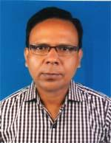 | DR. MD. YOUSUF ALI  F/Name: Md. Nawshad Ali  M/Name: Mrs. Beraful Begum  BM & DC Reg. No: 26823  NID: 8198503431822  Cell: 01711708015  Address: Asst. Prof. (Eye), Rajshahi Medical College , Rajshahi  Blood Group: O+
210 | Voter No  LM-5500210  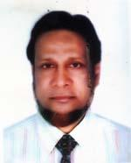 | DR. PROF. DR. MD. IQBAL BARI  F/Name: Md. Mahibur Rahman  M/Name: Sultana Razia Begum  BM & DC Reg. No: 19844  NID: 8198508264039  Cell: 01711811218  Address: 6/9, Shar-Sa-Road, Kazihata, Rajshahi  Blood Group: A+
211 | Voter No  LM-5500211  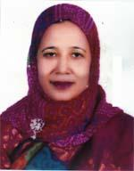 | DR. TANJILA ALAM  F/Name: Md. Shafiqul Alam  M/Name: Begum Shufia Khatun  BM & DC Reg. No: 14270  NID: 19598198508264038  Cell: 01713228341  Address: 619, Shar sa Road, Kazihata, Rajshahi  Blood Group: B+
212 | Voter No  LM-5500212  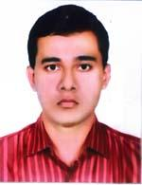 | DR. MD. TANBIR IQBAL  F/Name: Dr. Md. Iqbal Bari  M/Name: Dr. Tanjila Alam  BM & DC Reg. No: 57707  NID: 2691649100998  Cell: 01765651725  Address: Tanjila Orchid, Kazihata, Laxmipur, Thana-Rajpara, Dist-Rajshahi  Blood Group: AB+
213 | Voter No  LM-5500213  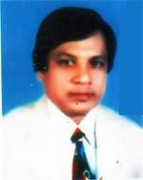 | DR. MD. ANWARUL KADER  F/Name: Md. Arshad Ali  M/Name: Most. Rezia Begum  BM & DC Reg. No: 13733  NID: 8198506400647  Cell: 01726172266  Address: 71/A Amid Dhara, Laxmipur, Rajshahi  Blood Group: O+
214 | Voter No  LM-5500214  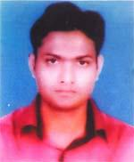 | DR. MD. KHIZIR HOSSAIN  F/Name: Md. Nazrul Islam  M/Name: Begum Sufia  BM & DC Reg. No: 51277  NID: 81985010364712  Cell: 01712073508  Address: Dept. of Auasstuesoa & ICU , RMCH  Blood Group: B+
215 | Voter No  LM-5500215  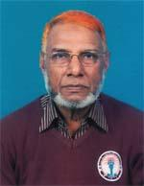 | DR. A. B. M. SELIMUZZAMAN  F/Name: Late Mr. Belayet Ali  M/Name: Late Rizia Khatun  BM & DC Reg. No: 6316  NID: 8192221355739  Cell: 01716390101  Address: Associate Professor. Dept. of Community Medicine Baruid Medical College, Rajshahi  Blood Group: A+
216 | Voter No  LM-5500216  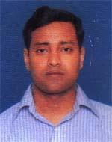 | DR. MD. AHSANUL HAQUE  F/Name: Md. Mahtab Uddin  M/Name: Khairun Nesa  BM & DC Reg. No: 49239  NID: 8198510366862  Cell: 01712218890  Address: Microbiology Department, Rajshahi Medical College  Blood Group: O+
217 | Voter No  LM-5500217  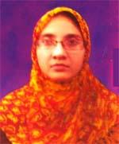 | DR. MST. RAWSONARA KHATUN  F/Name: Md. Abdur Rouf  M/Name: Mrs. Shajeda Begum  BM & DC Reg. No: 49014  NID: 19838198510362971  Cell: 01815267005  Address: B/7-F, Medical Campus, RMCH  Blood Group: AB+
218 | Voter No  LM-5500218  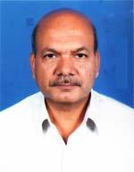 | DR. SANJIB KUMAR KARMAKAR  F/Name: Harendra Nath Karmakar  M/Name: Chapa Rani Karmakar  BM & DC Reg. No: 14194  NID: 8192220172877  Cell: 01715468450  Address: 194, Boaliapara, Post-Ghoramara, P.s-Boalia, Rajshahi  Blood Group: A+
219 | Voter No  LM-5500219  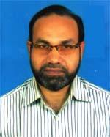 | DR. MD. HABIBUL ISLAM  F/Name: Md. Mofizul Islam  M/Name: Mrs. Arajmand Banu  BM & DC Reg. No: 23622  NID: 8198508260394  Cell: 01711348722  Address: Jnr. Consultant, UHC, Puthia, Rajshahi  Blood Group: AB+
220 | Voter No  LM-5500220  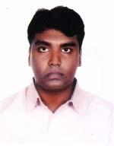 | DR. MOHAMMAD SHIHABUR RASHID  F/Name: Md. Abdur Rashid  M/Name: Arman Nahar  BM & DC Reg. No: 52573  NID: 19858192226332695  Cell: 01748972762  Address: Road-6, House-33, Padma Residential Area, Post-Padma Abasite, Rajshahi  Blood Group: AB+
221 | Voter No  LM-5500221  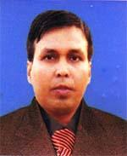 | DR. MD. GOLAM RABBANI  F/Name: Nur Mohammad Mondal  M/Name: Amina Khatun  BM & DC Reg. No: 37584  NID: 8198503432483  Cell: 01712150475  Address: 189/New Bilshimla, Rajpara, Rajshahi  Blood Group: B+
222 | Voter No  LM-5500222  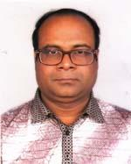 | DR. MUHAMMAD AMINUL ISLAM  F/Name: Md. Hesamul Haque  M/Name: Mrs. Hasina Banu  BM & DC Reg. No: 38917  NID: 8198514106730  Cell: 01817385230  Address: Department of Ent, RMCH  Blood Group: A+
223 | Voter No  LM-5500223  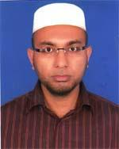 | DR. MD. NOOR KUTUBUL ALAM  F/Name: Abdul Kayum Sikdar  M/Name: Anjuman Ara Begum  BM & DC Reg. No: 46153  NID: 19823523208131754  Cell: 01711454168  Address: 4/B Urmee, Pilkhana, New Market, Dhaka  Blood Group: O+
224 | Voter No  LM-5500224  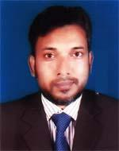 | DR. MD. NURUL ISLAM  F/Name: Md. Sorafotullah  M/Name: Amena Begum  BM & DC Reg. No: 31332  NID: 2699040723804  Cell: 01711905210  Address: 140/2 Uposhahar, Rajshahi  Blood Group: O+
225 | Voter No  LM-5500225  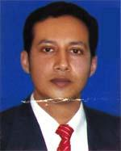 | DR. ABU SYEED MD. ABDULLAH  F/Name: Md. Israil Haq  M/Name: Mostari Haq  BM & DC Reg. No: 38681  NID: 8192219329060  Cell: 01781441155  Address: Matir Maya, 49, Professor Para, Choto Bongram Shalbagan, Post-Sopura, Rajshahi  Blood Group: A+
226 | Voter No  LM-5500226  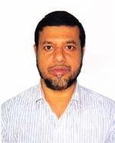 | DR. MD. AL MAMUN AR RASHID  F/Name: Md. Aminul Haque  M/Name: Nurun Nesa  BM & DC Reg. No: 27821  NID: 8127218386603  Cell: 01730301799  Address: Vill-Bholabari, Post-Paba, P.s-Shah mokhdum, Dist-Rajshahi  Blood Group: B+
227 | Voter No  LM-5500227  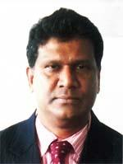 | DR. MD. ABDUR RASHID  F/Name: Late Reaz Uddin Sheikh  M/Name: Late Komela Khatun  BM & DC Reg. No: 25388  NID: 8198506400190  Cell: 01748803011  Address: # 185, Greaten Road, Vill-Laxmipur more, Gpo-6000, P.s-Rajpara, Dist-Rajshahi  Blood Group: AB+
228 | Voter No  LM-5500228  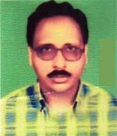 | DR. MD. ABDUL HAKIM  F/Name: Md. Abdur Rashid Mondol  M/Name: Mst. Anowara Begum  BM & DC Reg. No: 29850  NID: 8198503284009  Cell: 01712271619  Address: 100, Ward-27, Raninagor (Monnafer More), Kazla, Boalia, Rajshahi  Blood Group: B+
229 | Voter No  LM-5500229  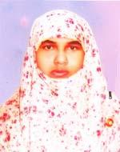 | DR. MST. MORIOM NESSA  F/Name: Md. Ismail Hossain  M/Name: Mst. Ambia Khatun  BM & DC Reg. No: 38264  NID: 2996352218154  Cell: 01711191271  Address: Padma Abasik, House No. -259/2, Boalia, Rajshahi  Blood Group: O+
230 | Voter No  LM-5500230  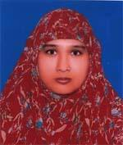 | DR. FATEMA SIDDQUA  F/Name: Late Shah Md. Yousuf Ali  M/Name: Late Rizia Bagum  BM & DC Reg. No: 27548  NID: 8192214344776  Cell: 01741546004  Address: 174/2, Upashahar, Post-Senanibub, Thana-Boalia, Dist-Rajshahi  Blood Group: B+
231 | Voter No  LM-5500231  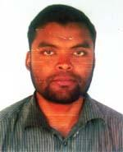 | DR. MD. MAHBUB HASAN  F/Name: Md. Abdul Mannan  M/Name: Halima Begum  BM & DC Reg. No: 64737  NID: 1976165152276  Cell: 01749589281  Address: Asst. Registion (Surgery), Islami Bank Medical College, Rajshahi  Blood Group: O+
232 | Voter No  LM-5500232  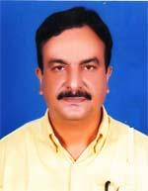 | DR. MD. MUNIRUL ABEDIN  F/Name: Md. Jainal Abedin  M/Name: Hasina Begum  BM & DC Reg. No: 18091  NID: 8198505391084  Cell: 01715205878  Address: Assistant Professor, Physiology Dept. Rajshahi Medical College  Blood Group: B+
233 | Voter No  LM-5500233  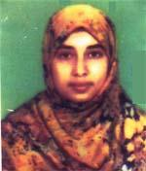 | DR. SUMMI LEUNARD KEYA  F/Name: Md. Enamul Haque  M/Name: Mrs. Farida Haque  BM & DC Reg. No: 49315  NID: 8194030121045  Cell: 01767424646  Address: 191, Terokhadia, P.s-Rajpara, Post-Cantonment, Dist-Rajshahi-6202  Blood Group: O+
234 | Voter No  LM-5500234  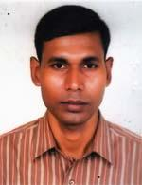 | DR. MD. GOLAM MOSTOFA  F/Name: Rawshon Ali  M/Name: Dalimun Nesa  BM & DC Reg. No: 33008  NID: 8198503437150  Cell: 01717571587  Address: Holding No. 167, Ward No. 3, Boddrompur, City Bypass, Rajshahi-6000  Blood Group: O+
235 | Voter No  LM-5500235  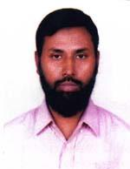 | DR. MD. REJAUL KARIM  F/Name: Mohd. Israil Hossain  M/Name: Most. Jahanara Begum  BM & DC Reg. No: 34424  NID: 8192219329026  Cell: 01712504704  Address: New Bilsimla, Rajpara, Rajshahi  Blood Group: B+
236 | Voter No  LM-5500236  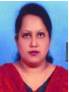 | DR. TANZILA SUBRINA RAHMAN  F/Name: Md Najibur Rahman  M/Name: Mrs Anjuman Banu  BM & DC Reg. No: A38436  NID: 6125221271198  Cell: +88 01726364559  Address: Pathology Dept, Rajshahi Medical Collage, Rajshahi.  Blood Group: B+
237 | Voter No  LM-5500237  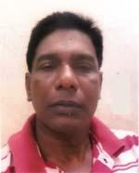 | DR. S. M. ASZAD HASAN  F/Name: Late Ismail Hossain Sardar  M/Name: Mrs. Rahela Khatun  BM & DC Reg. No: 47209  NID: 1028808704170  Cell: 01716105075  Address: Medical Centre, Rajshahi University, Rajshahi  Blood Group: A+
238 | Voter No  LM-5500238  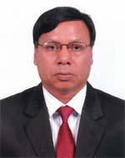 | DR. FAKIR MD. ABU ZAHID  F/Name: Late Del-mohammad Fakir  M/Name: Late Ayesha Khatun  BM & DC Reg. No: 16975  NID: 8194030129775  Cell: 01715039775  Address: Demo, Medical Centre,RU  Blood Group: O+
239 | Voter No  LM-5500239  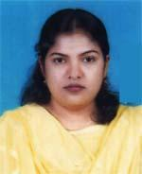 | DR. JAMAN ARA SOHELY  F/Name: Md. Jamal Uddin  M/Name: Mrs. Anowara Begum  BM & DC Reg. No: 39631  NID: 8192220171244  Cell: 01717082642  Address: 63-01, Nasir Sarker Road, Mirer Chock, Rajshahi  Blood Group: B+
240 | Voter No  LM-5500240  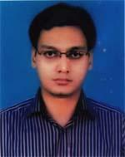 | DR. ALAM IFTEKHAR BELYAT  F/Name: Md. Towhidul Alam  M/Name: Mohsina Begum  BM & DC Reg. No: 53443  NID: 8198508263048  Cell: 01755245154  Address: Alam Vila, Holding No. 71, Kazihata, Greater Road, Gpo-6000, Rajpara, Rajshahi  Blood Group: B+
241 | Voter No  LM-5500241  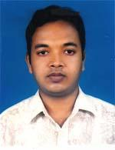 | DR. MD. SHAHIDULLAH KAISER  F/Name: Md. Wahiduzzaman  M/Name: Mst. Anjuman Ara  BM & DC Reg. No: 50862  NID: 6417947680616  Cell: 01717450635  Address: House No. 163, Ward-03, Anjuman Villa, Nottonbilshimla, Rajpara, Rajshahi-6000  Blood Group: A+
242 | Voter No  LM-5500242  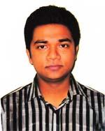 | DR. SK. MD. NAFIS KABIR  F/Name: Humayun Kobir Sheikh  M/Name: Nurun Nahar Begum  BM & DC Reg. No: 67271  NID: 19908192214000051  Cell: 01742188485  Address: 226/3, Sopna, Uposhahar, Rajshahi  Blood Group: A+
243 | Voter No  LM-5500243  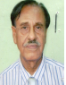 | DR. MD. HAFIZUDDIN KHAN  F/Name: Late Tamizuddin Khan  M/Name: Late Shasun Nahar Khan  BM & DC Reg. No: A27791  NID: 8127211150579  Cell: +88 01712900284  Address: Khan Mohol, New Bisunilla, Rajpara, Rajshahi.  Blood Group: O+
244 | Voter No  LM-5500244  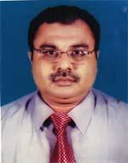 | DR. MD. INTEKHAB RAHMAN  F/Name: A. K. M. Alamgir  M/Name: Ms. Suriya Alamgir  BM & DC Reg. No: 29484  NID: 8198508261555  Cell: 01726641949  Address: 230 Das Pukur Rajshahi  Blood Group: B+
245 | Voter No  LM-5500245 | DR. MD NASIM AHMED  F/Name: Md Shawkat Ali Babu  M/Name: Nasima Begum  BM & DC Reg. No: A63432  NID: 19872716469299286  Cell: +88 01763107060  Address: Shampur, Rajshahi.  Blood Group: A+
246 | Voter No  LM-5500246  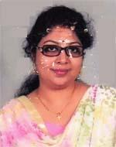 | DR. SUNANDITA SARKAR  F/Name: Santosh Kumar Sarkar  M/Name: Dolly Rani Sarkar  BM & DC Reg. No: 46282  NID: 19838192222318148  Cell: 01721612555  Address: 327, Sagarpara, Ghoramara, Rajshahi  Blood Group: O+
247 | Voter No  LM-5500247  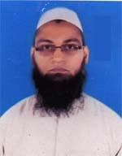 | DR. ASHIK IKBAL  F/Name: Abdullahel Baqui  M/Name: Momena Akhter  BM & DC Reg. No: 41463  NID: 19822690421351300  Cell: 01718273534  Address: Holding No-328/2, Upasahar, Rajshahi  Blood Group: O+
248 | Voter No  LM-5500248  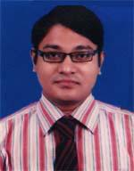 | DR. KH. NAFIZ RAHMAN  F/Name: Khondoker Mahbubur Rahman  M/Name: Nasreen Ara Khanum  BM & DC Reg. No: 56244  NID: 19878198510364587  Cell: 01717088641  Address: Kata Khali Bazar, Post-Shyampur,P.s-Motihar, Rajshahi  Blood Group: O+
249 | Voter No  LM-5500249  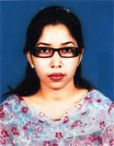 | DR. MST. MAHMUDA KHATUN  F/Name: Md. Golam Mostofa  M/Name: Mst. Kohinur Mostofa  BM & DC Reg. No: 62742  NID: 8198501417089  Cell: 01716175763  Address: Katakhali , post-Shyampur, Thana-Motihar, Rajshahi  Blood Group: B+
250 | Voter No  LM-5500250 | DR. MD ANAYET ULLAH  F/Name: Rahmat Ullah  M/Name: Most Shamsunnahar  BM & DC Reg. No: A14772  NID: 8192211367598  Cell: +88 01720192124  Address: 525/1 Kajihata, Loxmipur, Rahshahi.  Blood Group: A+
251 | Voter No  LM-5500251  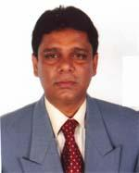 | DR. MD. GOLAM MAULA  F/Name: Dr. Md. Ramizul Karim  M/Name: Mst. Fatema Begum  BM & DC Reg. No: 24113  NID: 6919112792591  Cell: 01714743570  Address: 174, Chandipur, P.s-Rajpara, Rajshahi  Blood Group: O+
252 | Voter No  LM-5500252  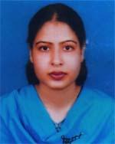 | DR. NAYEMA ISHRAT EASHA  F/Name: Khandaker Nurul Alam  M/Name: Hosne Ara Khanam  BM & DC Reg. No: 52189  NID: 8198510364016  Cell: 01717515056  Address: Dept. of Gynee & Obs, RMCH  Blood Group: B+
253 | Voter No  LM-5500253  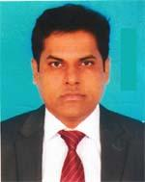 | DR. MD. ASIF HASNAIN (RUMI)  F/Name: Md. Ruhul Amin  M/Name: Fatema Khatun  BM & DC Reg. No: 56104  NID: 8198501417231  Cell: 01723644518  Address: House No.-232, Haragram Bazar, Post-Rajshahi Court, P.s-Rajpara, Dist- Rajshahi  Blood Group: A+
254 | Voter No  LM-5500254  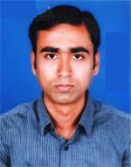 | DR. RAJIB SARKAR  F/Name: Jiten Dronath Sarkar  M/Name: Suchitra Rani  BM & DC Reg. No: 63225  NID: 8198510366878  Cell: 01717736039  Address: Vill-Atghori, Post-monigram, Thana-Bagha, Dist-Rajshahi  Blood Group: O+
255 | Voter No  LM-5500255  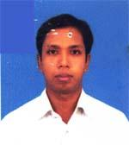 | DR. ASIM KUMAR  F/Name: Choytonna Karmokar  M/Name: Rekha Rani  BM & DC Reg. No: 60811  NID: 8123107583563  Cell: 01916208422  Address: Vill-Durgapur (hindu para), Post+P.s-Durgapur, Dist-Rajshahi  Blood Group: A+
256 | Voter No  LM-5500256  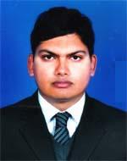 | DR. BIBHAS KUMAR SHARMA  F/Name: Brojo Gopal Sharma  M/Name: Asa Rani Sharma  BM & DC Reg. No: 61721  NID: 8198510364686  Cell: 01717143944  Address: Vill-Arni, Post-Arani, P.s-Bagha, Dist-Rajshahi  Blood Group: O+
257 | Voter No  LM-5500257  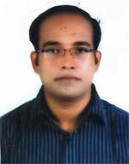 | DR. MIRZA MD. KAISER ELAHI  F/Name: Jasim Uddin Ahmed  M/Name: Zinnatun Nessa  BM & DC Reg. No: 56439  NID: 8192210360140  Cell: 01756266440  Address: 265/1, Baharampur, Gpo-6000, Rajpara, Rajshahi  Blood Group: AB+
258 | Voter No  LM-5500258  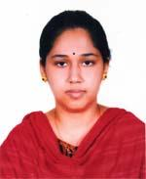 | DR. MOST. AMINA FERDOS  F/Name: Md. Alauddin Sarkar  M/Name: Most. Asma Sarker  BM & DC Reg. No: 54397  NID: 19858192227210417  Cell: 01916691422  Address: Vill-Baliapukur (H/N-99), Post-Ghoramara, P.s-Boalia, Dist-Rajshahi  Blood Group: B+
259 | Voter No  LM-5500259  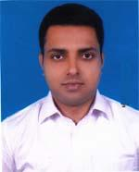 | DR. INDRASIS SANYEL (ANKUR)  F/Name: Asit Chandra Sanyel  M/Name: Rita Sanyel  BM & DC Reg. No: 58123  NID: 8524901006732  Cell: 01717821403  Address: House No. 325, Road No. 1, padma Residential Area, Rajshahi  Blood Group: B+
260 | Voter No  LM-5500260  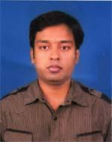 | DR. SUMAN PAUL  F/Name: Monoranjan Paul  M/Name: Sumita Paul  BM & DC Reg. No: 56332  NID: 8198503432010  Cell: 01717877275  Address: 114/1, Laxmipur, Rajshahi  Blood Group: B+
261 | Voter No  LM-5500261  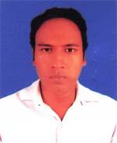 | MD. MIJANUL HAQUE SHOWROV  F/Name: Md. Shamsul Haque  M/Name: Fatema Khatun  BM & DC Reg. No: 57343  NID: 8198506403735  Cell: 01716357934  Address: H-108, Greater Road, laxmipur, Rajshahi  Blood Group: A+
262 | Voter No  LM-5500262  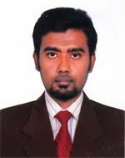 | DR. ADNAN MUEED  F/Name: Abdur Raquib  M/Name: Dil Afroza Begum  BM & DC Reg. No: 61724  NID: 19878194028198176  Cell: 01711218127  Address: 139-Kazla, Motihar, Rajshahi-6204  Blood Group: O+
263 | Voter No  LM-5500263  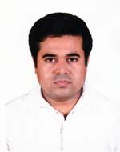 | DR. MD. HASAN AL KHURSHID  F/Name: Md. Emdadul Huq  M/Name: Nurjahan Begum  BM & DC Reg. No: 52259  NID: 8192214345307  Cell: 01717095237  Address: 222, Vill-Ramchondropur, Post-Ghoramara, Thana-Boalia, Dist-Rajshahi, 6100  Blood Group: A+
264 | Voter No  LM-5500264  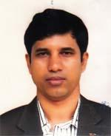 | DR. MILON KUMAR CHOWDHURY  F/Name: Dev Proshad Chowdhury  M/Name: Jamuna Rani Chowdhury  BM & DC Reg. No: 40478  NID: 8714394962612  Cell: 01712618556  Address: 528/1, Qazihata, Rajpara, Rajshahi  Blood Group: B+
265 | Voter No  LM-5500265  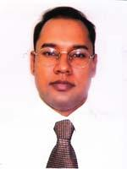 | DR. MD. NAZMUL HUDA  F/Name: Md. Shamsul Huda  M/Name: Mrs. Nargis Dilora Begum  BM & DC Reg. No: 26170  NID: 8192213103779  Cell: 01915069617  Address: 172, Kazirgong, Rajshahi-6000  Blood Group: A+
266 | Voter No  LM-5500266  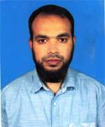 | DR. MD. ASIFUZZAMAN  F/Name: Md. Badiuzzaman  M/Name: Mst. Safiqun Nahar  BM & DC Reg. No: 48253  NID: 8192214346156  Cell: 01712122857  Address: Assistant Registrar. Medicine Unit-2, RMCH  Blood Group: O+
267 | Voter No  LM-5500267  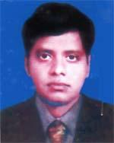 | DR. MD. FAISAL BIN SELIM KHAN  F/Name: Md. Selim Uddin Khan  M/Name: Most. Ferdousi Khan  BM & DC Reg. No: 48322  NID: 1822303130051  Cell: 01712532122  Address: W-13, Mu-11, RMCH  Blood Group: O+
268 | Voter No  LM-5500268  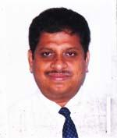 | DR. SANDIPAN GHOSE  F/Name: Late Dr. Ramendra Nath Ghose  M/Name: Mrs. Chhanda Ghose  BM & DC Reg. No: 23401  NID: 8194030127439  Cell: 01718062446  Address: Asst. Registrar, Nephrology Dept, Rajshahi Medical College Hospital  Blood Group: O+
269 | Voter No  LM-5500269  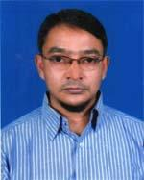 | DR. MD. RASEUL KABIR  F/Name: Late Shamshu Uddin  M/Name: Late Jahanar Begum  BM & DC Reg. No: 28060  NID: 8192215245494  Cell: 01712552092  Address: Registrar, Nepwrology, RMCH  Blood Group: B+
270 | Voter No  LM-5500270  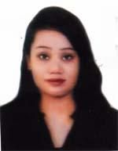 | DR. SHIFAT SHAFIN  F/Name: Minhaj Uddin Md. Seraj  M/Name: Lutfa Begum  BM & DC Reg. No: 51579  NID: 8192227212353  Cell: 01716298957  Address: Ushashi C/32, H-225, Raninagar, Kajla-6204, Boalia, Rajshahi  Blood Group: A+
271 | Voter No  LM-5500271  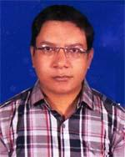 | DR. MD. SAIFUL ISLAM  F/Name: Md. Khairul Islam  M/Name: Mst. Hasna Begum  BM & DC Reg. No: 34294  NID: 6926307375007  Cell: 01928718464  Address: H # 647/1, W-24, Ramchandrapur, Khorbora, Ghoramara, Boalia, Rajshahi  Blood Group: O+
272 | Voter No  LM-5500272  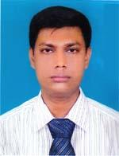 | DR. N. S. M. MOMTAZUL ISLAM  F/Name: Md. Monirul Islam  M/Name: Begum Momtaz Ara Islam  BM & DC Reg. No: 410061  NID: 8192214345849  Cell: 01715658605  Address: 26/2 (1st Floor), Housing Estate , Upashahar, Post-Cantonment, Thana-Boalia, Rajshahi  Blood Group: A+
273 | Voter No  LM-5500273  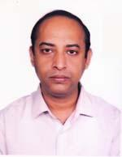 | DR. MD. ZAHIRUL HAQUE  F/Name: Md. Nurul Haque  M/Name: Tahera Begum  BM & DC Reg. No: 28716  NID: 2697557397817  Cell: 01712000918  Address: Rajshahi Medical Collage Rajshahi.  Blood Group: AB+
274 | Voter No  LM-5500274  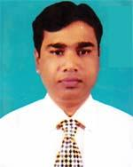 | DR. MD. SHAHIDUL ISLAM  F/Name: Md. Moklasar Rahman  M/Name: Most. Altafon Bibi  BM & DC Reg. No: 32388  NID: 8198503438626  Cell: 01712617257  Address: 551/1, Mohis Bathan, Rajshahi Court, Rajpara, Rajshahi  Blood Group: O+
275 | Voter No  LM-5500275  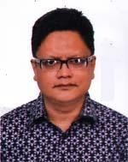 | DR. MD. PERVEZ AMIN  F/Name: Md. Amin Ullah  M/Name: Mst. Khadiza Khatoon  BM & DC Reg. No: 20130  NID: 8192214344116  Cell: 01715804202  Address: 23, Grotor Road, Luxmipur, Rajshahi-6000  Blood Group: AB+
276 | Voter No  LM-5500276  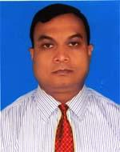 | DR. MD. MUNZUR ALAHI  F/Name: Md. Moyen Uddin  M/Name: Most. Hafiza Khatun  BM & DC Reg. No: 23362  NID: 8198503438363  Cell: 01716180626  Address: 5/B, Suvechcha Nibas, Rajpara, Rajshahi  Blood Group: A+
277 | Voter No  LM-5500277  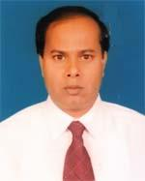 | DR. MUKUL KUMAR SARKAR  F/Name: Late Baidaynath Sarkar  M/Name: Neoty Sarkar  BM & DC Reg. No: 30806  NID: 6404727755247  Cell: 01718170987  Address: 501/1, Kazihata, Rajpara, Rajshahi  Blood Group: B+
278 | Voter No  LM-5500278  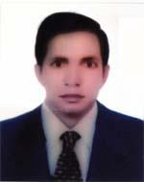 | DR. MD. KAFIL UDDIN  F/Name: Md. Lutfal Haque  M/Name: Mst. Sufia Khatun  BM & DC Reg. No: 20091  NID: 2699501946718  Cell: 01716174709  Address: H # 6/E, Medical College Campus, Rajshahi Medical College, Rajshahi  Blood Group: B+
279 | Voter No  LM-5500279  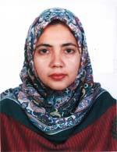 | DR. NIGAR SULTANA  F/Name: Md. Ehsanul Haque  M/Name: Mrs. Rokeya Begum  BM & DC Reg. No: 24481  NID: 8192227378652  Cell: 01770300543  Address: 65, Tikapara, Post-Ghoramara, P.s-Boalia, Rajshahi  Blood Group: O+
280 | Voter No  LM-5500280  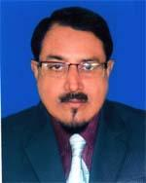 | DR. S. M. ASHRAF HOSSAIN  F/Name: S. M. Shahadat Hossain  M/Name: Anjumanara Begum  BM & DC Reg. No: 12410  NID: 8198505395288  Cell: 01710967400  Address: Associate Prof. & Head of Pathology , Islami Bank Medical College, Rajshahi  Blood Group: A+
281 | Voter No  LM-5500281  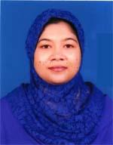 | DR. SULTANA NAZNIN  F/Name: Late Ashraful Islam  M/Name: Mahmuda Begum  BM & DC Reg. No: 37933  NID: 8192214345985  Cell: 01712130555  Address: 149/3, Uposhohor Housing Estate sopura Rajshahi  Blood Group: A+
282 | Voter No  LM-5500282  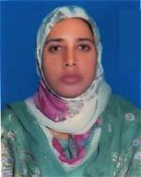 | DR. MST. ABEDA KHATUN  F/Name: Late Mir Abed Ali  M/Name: Hafiza Begum  BM & DC Reg. No: 36706  NID: 19768198503438  Cell: 01711989436  Address: 205 South Breeze, Medical Bondhogate, New Bilsimla,Rajpara, Rajshahi  Blood Group: O+
283 | Voter No  LM-5500283  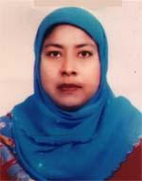 | DR. MONIRA NAJNIN  F/Name: Dr. Md. Habibur Rahman  M/Name: Mrs. Momtaj Begum  BM & DC Reg. No: 38389  NID: 19798198506402651  Cell: 01712517538  Address: 98/3, Bohoroumpur, Rajpara, Rajshahi-6000  Blood Group: B+
284 | Voter No  LM-5500284  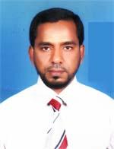 | DR. A K M KAMRUZZAMAN  F/Name: Md. Abdur Razzaque  M/Name: Most. Anwara Begum  BM & DC Reg. No: 25647  NID: 8192214342473  Cell: 01713209516  Address: B/462, Upashahar, Rajshahi  Blood Group: O+
285 | Voter No  LM-5500285 | DR. MD. SHAMEEM HOSSAIN CHOWDHURY  F/Name: Md. Motaher Hossain Chowdhury  M/Name: Mrs. Rokeya Begum  BM & DC Reg. No: 31194  NID: 8192209253220  Cell: 01715319093  Address: 270 Hossani Gonj, Boalia, Rajshahi-6000  Blood Group: B+
286 | Voter No  LM-5500286  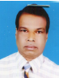 | DR. MD ABDUL KHALEQUE  F/Name: Md Abdus Sattar  M/Name: Most Maleka Khatun  BM & DC Reg. No: A12894  NID: 8192214344807  Cell: +88 01711812740  Address: Rajshihi Medical Collage, Rajshihi.  Blood Group: A+
287 | Voter No  LM-5500287  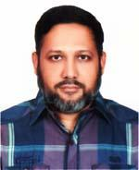 | DR. MD. MOSHIDUR RAHMAN  F/Name: Md. Ataur Rahman  M/Name: Tahera Begum  BM & DC Reg. No: 29981  NID: 8192227378650  Cell: 01716311435  Address: 65, Tikapara, Ghoramara, Boalia, Rajshahi  Blood Group: B+
288 | Voter No  LM-5500288  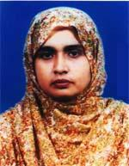 | DR. AREFA SULTANA  F/Name: Md. Idris Ali Miah  M/Name: G. A. Hasina Zahan  BM & DC Reg. No: 24031  NID: 8192219325232  Cell: 01713228362  Address: Upazilla Health Complex, Mohon pur, Rajshahi  Blood Group: B+
289 | Voter No  LM-5500289  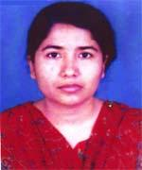 | DR. ROKSHANA PERVIN  F/Name: Md. Golam Mostafa  M/Name: Most. Rahela Begum  BM & DC Reg. No: 47738  NID: 8192214343810  Cell: 01721716145  Address: 71/2 Uposhor, Cantonment, Boalia, Rajshahi  Blood Group: O+
290 | Voter No  LM-5500290  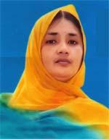 | DR. KHONDOKAR SEHELI NASRIN LINA  F/Name: Khondokar Abdur Rahman  M/Name: Mrs. Razia Begum  BM & DC Reg. No: 25671  NID: 3218213561718  Cell: 01718242180  Address: House No. -151, Sector-2, Upashahor, Housing State, Rajshahi  Blood Group: B+
291 | Voter No  LM-5500291  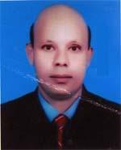 | DR. A. K. M. SHAHAB UDDIN  F/Name: Late Rofique Uddin  M/Name: Mrs. Shohida Begum  BM & DC Reg. No: 24835  NID: 8192224371789  Cell: 01818301202  Address: Bow Bezer, Kedurmor, Ghoramara, Ramchandrapur, Rajshahi  Blood Group: A+
292 | Voter No  LM-5500292  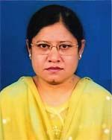 | DR. FARAH DEEBA  F/Name: Md. Kayem Uddin Sarder  M/Name: Late Lutfunnesa  BM & DC Reg. No: 19376  NID: 8198508261471  Cell: 01916208362  Address: E/6, Suvescha Nibash, 14/5, Betia para, Rajpara, Gpo-6000, Rajshahi  Blood Group: A+
293 | Voter No  LM-5500293  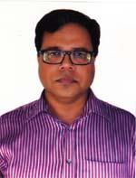 | DR. SHAH MD. AHSAN SHAHID  F/Name: Shah Md. Golam Shadidullah  M/Name: Mrs. Asma-ul-hosna  BM & DC Reg. No: 25670  NID: 3218213561717  Cell: 01711277286  Address: Asst. Prof. Pediatric Surgery, RMCH, W-9, Rajshahi Medical College Hospital  Blood Group: A+
294 | Voter No  LM-5500294  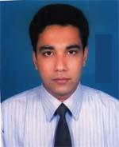 | DR. PARTHO MONI BHATTACHARYYA  F/Name: Parimal Bhattacharyya  M/Name: Gopa Bhattacharyya  BM & DC Reg. No: 36951  NID: 8198501410223  Cell: 01715059079  Address: Vill-Horogram, P.s-Rajpara, Post-Rajshahi Court, 6201, Ward no.-1, House no.-2, Dist-Rajshahi  Blood Group: B+
295 | Voter No  LM-5500295  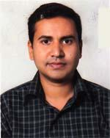 | DR. MD. ALI MAZRUI RAHMAN  F/Name: Dr. Md. Monsur Rahman  M/Name: Mrs. Mahfila Afrif  BM & DC Reg. No: 50896  NID: 19858113159511214  Cell: 01712567383  Address: 130, Kazihata DB Road, Rajpara, Rajshahi-6000  Blood Group: A+
296 | Voter No  LM-5500296  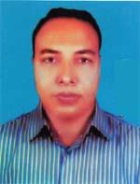 | DR. ISTIAK AHMED  F/Name: Naimuddin Ahmed  M/Name: Zobeda Begum  BM & DC Reg. No: 38222  NID: 2693622310446  Cell: 01711033581  Address: 513, Dorikarbona, Rajshahi  Blood Group: A+
297 | Voter No  LM-5500297  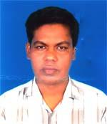 | DR. MD. GOLAM MORTUZA  F/Name: Md. Abdul Jalil  M/Name: Mrs. Halima Begum  BM & DC Reg. No: 39371  NID: 8524904042894  Cell: 01712933563  Address: Registrar, Dept. of Surgery, RMCH Register Terokhadia, Colleger Para Rajshahi.  Blood Group: A+
298 | Voter No  LM-5500298  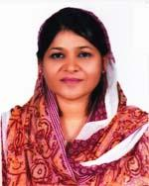 | DR. ISRAT ARA  F/Name: Md. Emran Ali  M/Name: Mst. Amina Khatun  BM & DC Reg. No: 22685  NID: 8198505394830  Cell: 01719751964  Address: 66, Mohishbathan, Rajshahi Court, Rajshahi  Blood Group: A+
299 | Voter No  LM-5500299  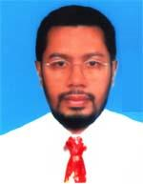 | DR. SYED SIRAJUL ISLAM  F/Name: Mir Mozammel Haq  M/Name: Fatema Khatoon  BM & DC Reg. No: 17967  NID: 8198510365078  Cell: 01715267462  Address: Asst. Prof. Pediatric Surgery, Rajshahi Medical College, Rajshahi  Blood Group: AB+
300 | Voter No  LM-5500300  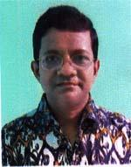 | DR. MD. ABDUL BATIN  F/Name: Late Afaz Uddin Ahmed  M/Name: Late Momena Khatun  BM & DC Reg. No: 24614  NID: 8198503430916  Cell: 01711460170  Address: 235/1, Dingadoba, Rajshahi  Blood Group: B+
301 | Voter No  LM-5500301  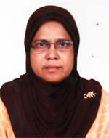 | DR. SHARIFA BEGUM  F/Name: Late Md. Janab Ali  M/Name: Mrs. Hamida Khatun  BM & DC Reg. No: 18224  NID: 8198506401607  Cell: 01768494169  Address: 212, Luxmipur, T. B. Road, Rajshahi  Blood Group: A+
302 | Voter No  LM-5500302  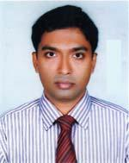 | DR. RAJESH KUMAR GHOSE  F/Name: Ramesh Chandra Ghose  M/Name: Namita Ghose  BM & DC Reg. No: 36108  NID: 8192227219879  Cell: 01715405881  Address: House No.-12, Sheroil Mathpukur, Ghoramara, Boalia, Rajshahi-6100  Blood Group: O+
303 | Voter No  LM-5500303  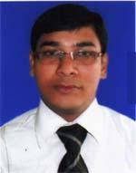 | DR. GULAM KAZEM ALI AHMAD  F/Name: Gulam Murtaza  M/Name: Monowara Begum  BM & DC Reg. No: 45802  NID: 8192214346497  Cell: 01712111107  Address: 68/2, Upashahar Housing Estate, Rajshahi  Blood Group: A+
304 | Voter No  LM-5500304  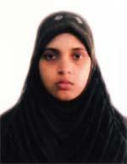 | DR. FARHANA YEASMIN  F/Name: Late A. H. M. Shamsul Huque  M/Name: Mrs. Meherun Nessa  BM & DC Reg. No: 53370  NID: 19868192214346224  Cell: 01717853459  Address: 68/2, Upashahar Housing Estate, Rajshahi  Blood Group: A+
305 | Voter No  LM-5500305  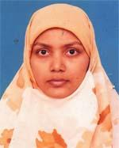 | DR. MIRA AKHTER  F/Name: Mozaher Ali  M/Name: Nargis Akhter  BM & DC Reg. No: 47056  NID: 8192209250675  Cell: 01718408339  Address: Pathology Department, Rajshahi Medical College Hospital  Blood Group: A+
306 | Voter No  LM-5500306  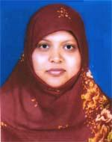 | DR. MOUSOMI SARKER  F/Name: Abdul Majid Sarker  M/Name: Mst. Rubia Sarker  BM & DC Reg. No: 45840  NID: 8192214980998  Cell: 01720466388  Address: Majid Manjil 448, Bahrampur, Rajpara, Thana-rajshahi-6000 office OSD, DG office, Mohakhali, Dhaka  Blood Group: B+
307 | Voter No  LM-5500307  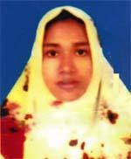 | DR. MST. MANJILA KHATUN  F/Name: Md. Serajul Islam  M/Name: Mst. Amena Khatun  BM & DC Reg. No: 42459  NID: 8192214341725  Cell: 01712081262  Address: Upashahar, B-347, Sector-1, Post-Sopura, osd,dg office, Mohakhali, Dhaka  Blood Group: O+
308 | Voter No  LM-5500308  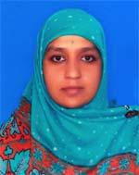 | DR. MST. SULTANA AKTAR  F/Name: Md. Abdul Momin Khan  M/Name: Mst. Mahbuba Begum  BM & DC Reg. No: 36057  NID: 6919112792583  Cell: 01739935787  Address: 174, Chandipur, P.s-Rajpara, Rajshahi  Blood Group: O+
309 | Voter No  LM-5500309  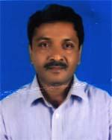 | DR. SUBRATA KUMAR PRAMANIK  F/Name: Late Kshitish Chandra Pramanik  M/Name: Sabita Pramanik  BM & DC Reg. No: 23413  NID: 8192226331395  Cell: 01710894625  Address: 279/3, Kazihata, Gpo-6000, Thana-Rajpara, Dist-Rajshahi  Blood Group: AB+
310 | Voter No  LM-5500310  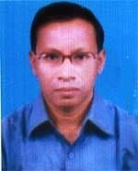 | DR. KAZI A. S. M. SHAMIM PARVEZ  F/Name: Late Kazi Ayub Ali  M/Name: Late Hasina Begum  BM & DC Reg. No: 17777  NID: 8524907086843  Cell: 01712566164  Address: Assistant Professor, paediatric Nebhrology, Rajshahi Medical College, Rajshahi  Blood Group: A+
311 | Voter No  LM-5500311  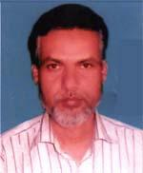 | DR. MD. MOZAMMEL HAQUE  F/Name: Md. Belayet Ali  M/Name: Lalmon Begum  BM & DC Reg. No: 21016  NID: 2697557397807  Cell: 01712501649  Address: 129, Upor Vadra, Rajshahi  Blood Group: B+
312 | Voter No  LM-5500312  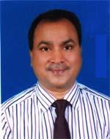 | DR. M. A. HANNAN  F/Name: Md. Abdur Rahman  M/Name: Ofela Begum  BM & DC Reg. No: 26782  NID: 19708192214344173  Cell: 01711348122  Address: Lotus Park, 153/2 Housing Estate, Upashahar, Rajshahi  Blood Group: B+
313 | Voter No  LM-5500313  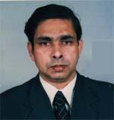 | DR. MOHD. HARUN OR RASHID  F/Name: Mohd. Habibur Rahman  M/Name: Dawlaton Nesa  BM & DC Reg. No: 19991  NID: 8198510364148  Cell: 01711904778  Address: Asst. Prof. Hepatology Department, Rajshahi Medical College  Blood Group: O+
314 | Voter No  LM-5500314  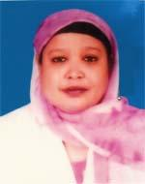 | DR. ZIBAN NAHAR  F/Name: Late Jalilur Rahman  M/Name: Late Sufia Begum  BM & DC Reg. No: 13737  NID: 8198510364937  Cell: 01711894849  Address: Assit. Prof. Gynoeclogy Rajshahi Medical College  Blood Group: AB+
315 | Voter No  LM-5500315  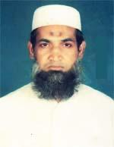 | DR. MD. MOKSEDUR RAHMAN  F/Name: Late Kafil Uddin  M/Name: Asiya Khatun  BM & DC Reg. No: 15275  NID: 8192209253583  Cell: 01711142664  Address: D-398, Mukta Villa, Hossainiganj, Rajshahi  Blood Group: B+
316 | Voter No  LM-5500316  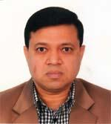 | DR. MOHAMMAD HASAN TARIK  F/Name: Md. Habibur Rahman  M/Name: Suriya Begum  BM & DC Reg. No: 24435  NID: 8198506400690  Cell: 01712167593  Address: 5-A, Arc South Breeze, Medical Bondhogate, New Bilshimla, Rajshahi  Blood Group: B+
317 | Voter No  LM-5500317  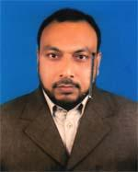 | DR. MD. SAIFUL ISLAM  F/Name: Md. Daroad Ali  M/Name: Mst. Asia Khatun  BM & DC Reg. No: 20026  NID: 8192214344758  Cell: 01711302932  Address: Associate Prof. Radiology & Imaging Department, Rajshahi Medical College  Blood Group: B+
318 | Voter No  LM-5500318  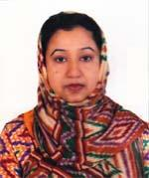 | DR. SHAHIN MAHMUDA  F/Name: Md. Abdus Sattar  M/Name: Anowara Sattar  BM & DC Reg. No: 23094  NID: 8192213103092  Cell: 01715405897  Address: Associate Prof. Physiology Dept. Rajshahi Medical College, Rajshahi  Blood Group: O+
319 | Voter No  LM-5500319  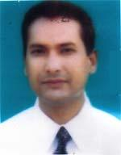 | DR. S. M. ASAFUDULLAH  F/Name: Md. Ashraf Ali Sarder  M/Name: Begum Aklima Sefali  BM & DC Reg. No: 16485  NID: 8192213103090  Cell: 01715059262  Address: Associate Prof. Pathology Dept. Rajshahi Medical College, Rajshahi  Blood Group: A+
320 | Voter No  LM-5500320  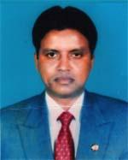 | DR. MD. MONIRUZZAMAN SARKER  F/Name: Late Abdul Jabbar Sarker  M/Name: Mst. Zinnat Ara Begum  BM & DC Reg. No: 23327  NID: 8198503433675  Cell: 01715121824  Address: House-9, Notun Bilshimla, Cantonment Road, Rajshahi  Blood Group: O+
321 | Voter No  LM-5500321  No Image | DR. MD. NASIM HOSSAIN  F/Name: Late Shahjahan Ali  M/Name: Mrs. Amena Khatun  BM & DC Reg. No:  NID:  Cell: 01715-508534  Address: Junior Cnsultant (Ophthalmology Rajshahi Medical College Hospital, Rjshahi.  Blood Group: B+
322 | Voter No  LM-5500321  No Image | DR. MD. NASIM HOSSAIN  F/Name:  M/Name:  BM & DC Reg. No:  NID:  Cell: 01715-508534  Address: Rajshahi Medical College Hospital, Rajshahi.  Transfered From BMA Dinajpur Br.  LM-1500080  Blood Group:  TRANSFERED to BMA Dhaka City  LM-1405543
323 | Voter No  LM-5500322  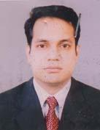 | DR. ABU SHAHIN MD. MAHBUBUR RAHMAN  F/Name: Alhaj Md. Mojibur Rahman  M/Name: Alhaj. Nurjahan Begum  BM & DC Reg. No: 34910  NID: 7026614195499  Cell: 01763248448  Address: Asstt. Professor Of Medicine, Rajshahi Medical College Hosptial  Rajshahi.  Blood Group: O+
324 | Voter No  LM-5500323  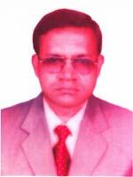 | DR. MD. ABDUS SAMAD  F/Name: Late Aleef Ali  M/Name: Late Nekjan Begum  BM & DC Reg. No: 23526  NID: 8192219324389  Cell: 01711302274  Address: Consultant Diabetologyst Director, Sabera Memorial Diabetic Centra, Shiroil Koloney, Road-1, P.O Ghoramara, Rajshahi.  Blood Group: A+
325 | Voter No  LM-5500324  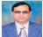 | DR. MD. ELAHI BAKS  F/Name:  M/Name:  BM & DC Reg. No:  NID:  Cell:  Address: TH & FPO THC Sapohar Naogaon  Blood Group:

